Open Waters User Guide

[Type the document subtitle]

5/5/2015

OTIE

EP-D-11-060

Table of Contents

Introduction 2

Analyze Data Section 3

Upload Data Section 15

Configure Upload 17

Configure Possible Fields For MS Excel File Uploads 18

Manual Data Entry 21

Organization 21

Projects 22

Monitoring Locations 23

Activities 25

Analyze Configuration 28

Administration Section 29

My Account 29

User Management 29

Role Management 29

App Settings 31

WQX Management 32

Org Characteristic Settings 33

Column Admin 34

Synch Data 35

# Introduction

Open Waters is a web-based water quality data management system that allows you to manage water quality monitoring locations, samples, results, and projects. The intended audience is tribal, state, or local volunteer water quality data managers, who collect and manage water quality data, and have the need to submit this data to EPA's WQX program. Open Waters is unique in that people can manage their data locally, but submission to EPA is completely automated and handled behind-the-scenes, thus eliminating the burden of separate data submission to EPA. There is also a map-based data selection interface that allows for viewing and analyzing existing water quality data.

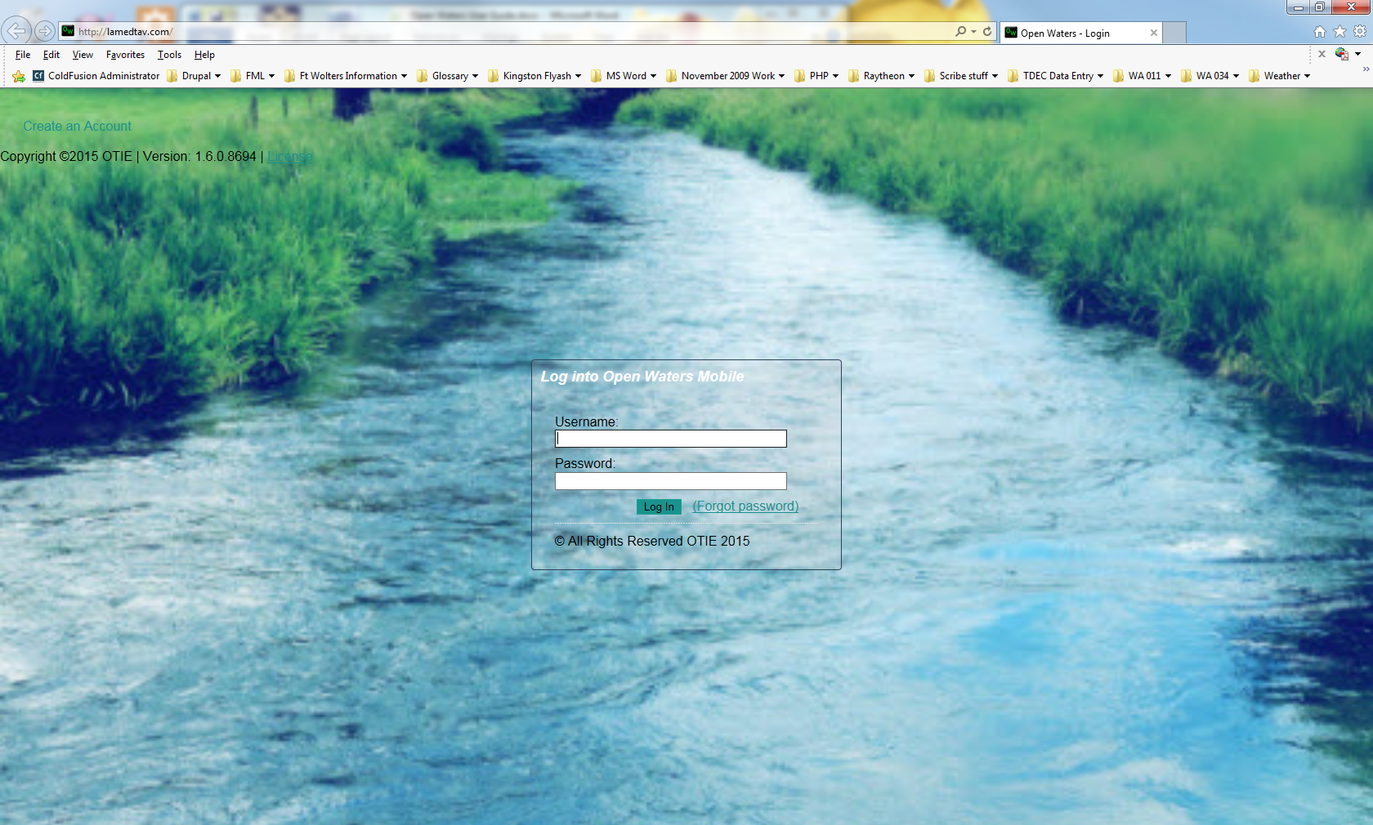

After logging in to the website, a dashboard screen is displayed. The dashboard shows the a summary of the organizations, projects, samples, results and WQX submissions associated with the user, as well as a map displaying the user’s sampling locations.

From the dashboard screen, the user can choose to upload new MS Excel spreadsheet data, edit existing data, analyze data or perform administrative tasks such as user management, changing application settings, or synchronizing data with the WQX.

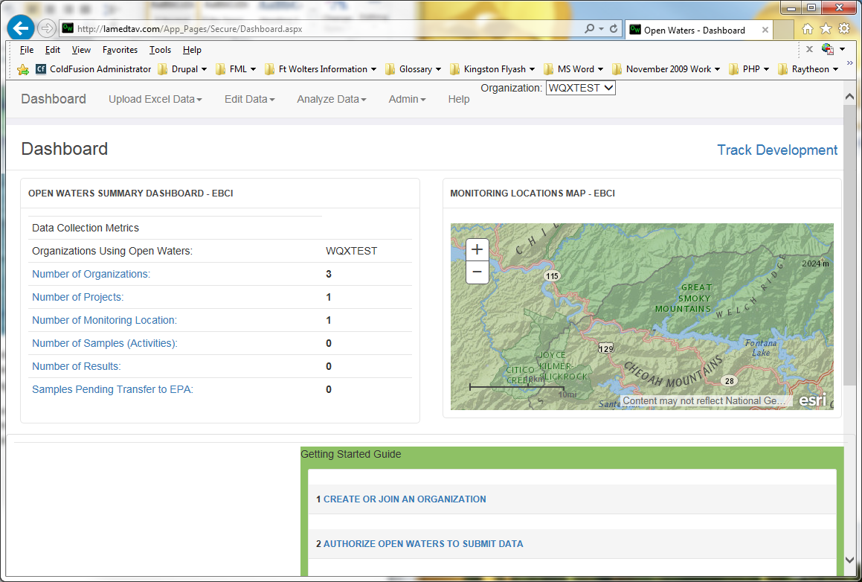

# Analyze Data Section

To view and analyze existing data, click on the down arrow next to ***Analyze Data*** on the menu and choose ***Search & Analyze.***

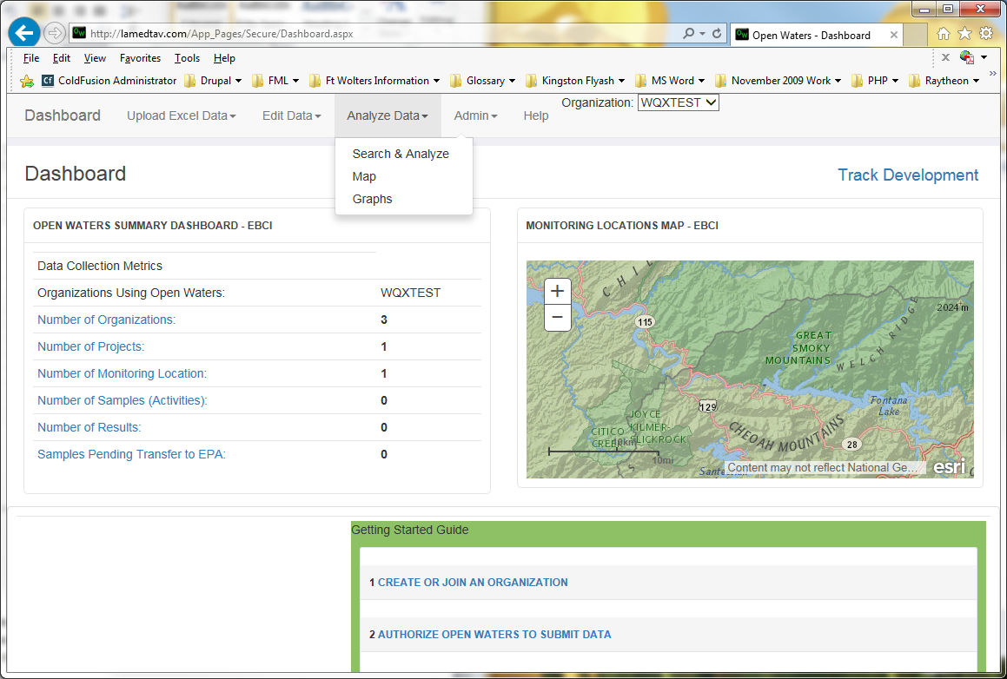

A map selection interface is displayed, showing the local sampling data points for your organization(s). You can choose among several base layer map views including: street, topographical or imagery by selecting the down arrow next to the **Base Layer** menu item.

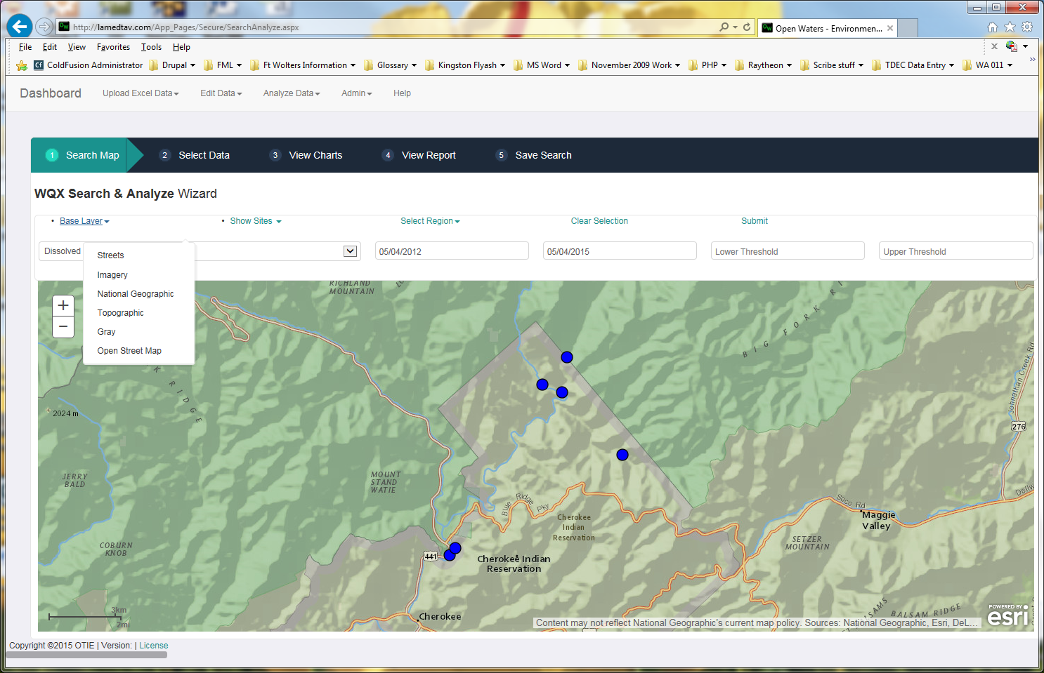

To zoom in or out of the map, click either the plus “**+**” icon (to zoom in) or the minus “**-**“ icon (to zoom out).

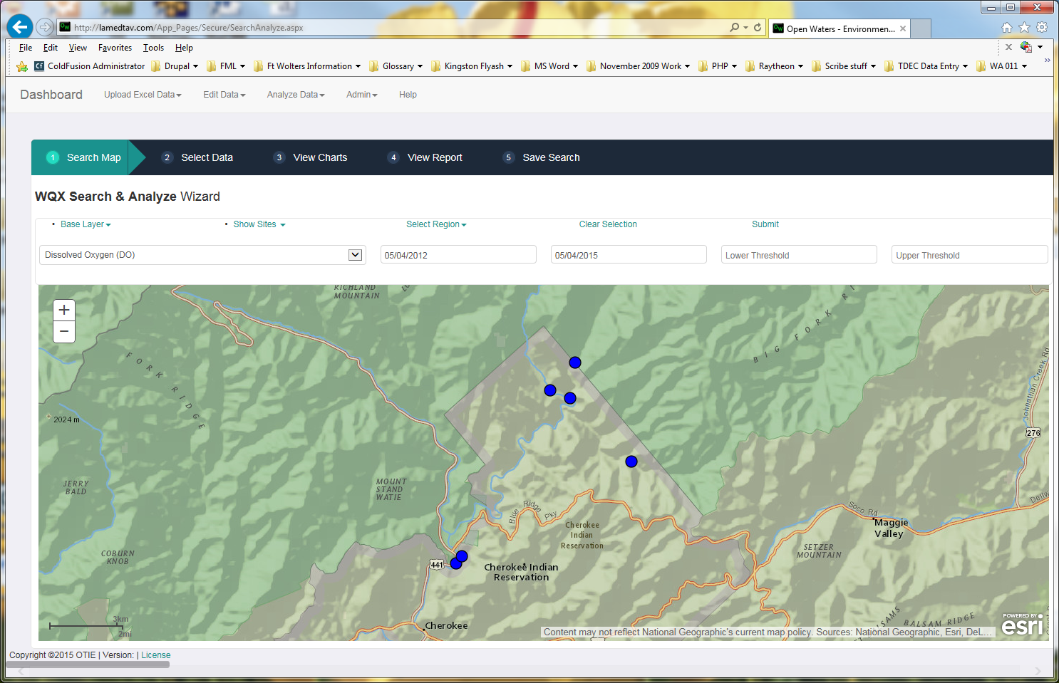

By clicking on the arrow next to the ***Show Sites*** menu item, you can choose whether to display data from ***Local*** monitoring sites only, ***Water Quality Portal*** monitoring site data, or ***Water Quality Portal – All*** data, which displays monitoring data from other relevant organizations in addition to the Water Quality Portal data. Some of these organizations may include: USGS, National Park Service, and State water resources organizations.

Placing the cursor on a monitoring site symbol will display a tool tip showing that site’s organization.

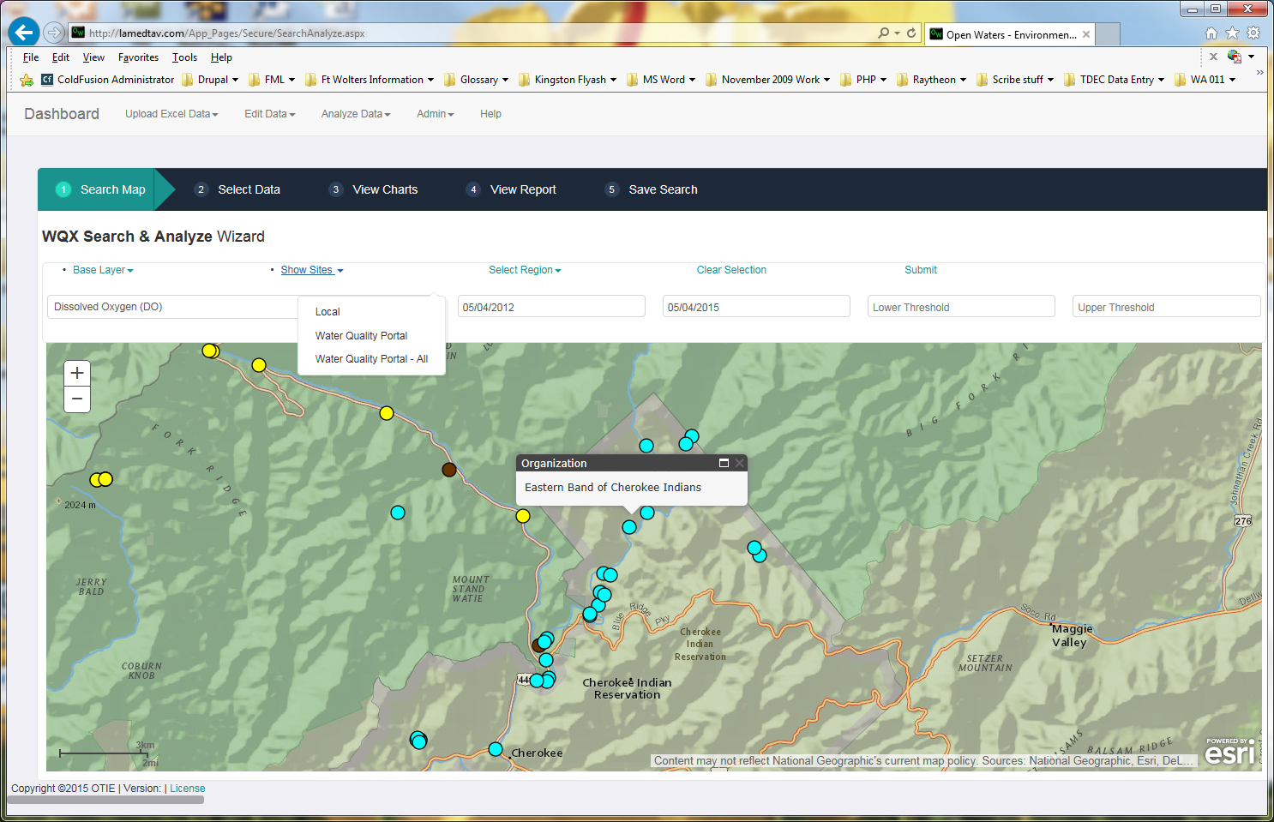

Choose the data parameter for which you would like to view the data and enter a range of sampling dates. If you wish, you may also set an appropriate upper and lower threshold to be displayed on the resulting data visualization graphs.

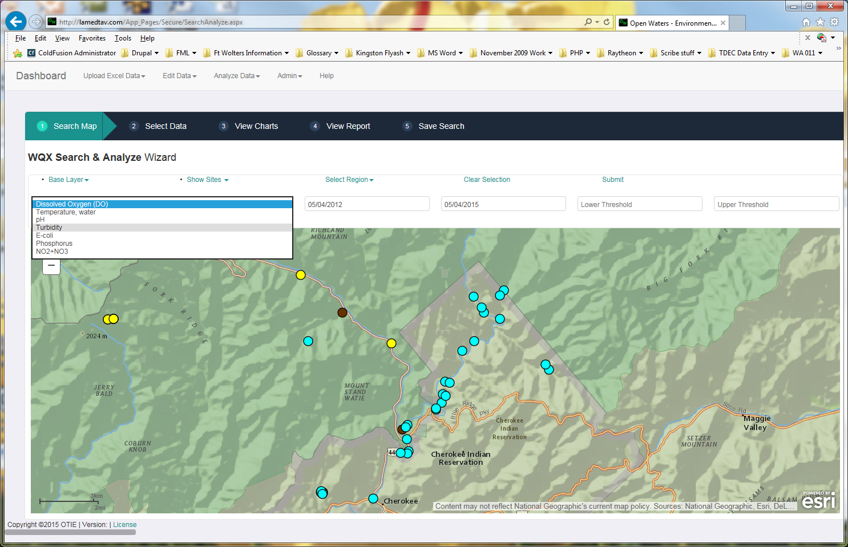

You can view the selected data parameters for a group of monitoring sites by clicking the down arrow next to ***Select Region*** on the menu and choosing either ***Rectangle*** or ***Polygon***. Click on the map and drag to select the group of sites you would like to examine. The selected area will turn yellow and the selected sites will be displayed as red circles. If you are not satisfied with the area selected, click on the ***Clear Selection*** menu item and try the selection process again. When you are satisfied with your choices, click ***Submit*** on the menu.

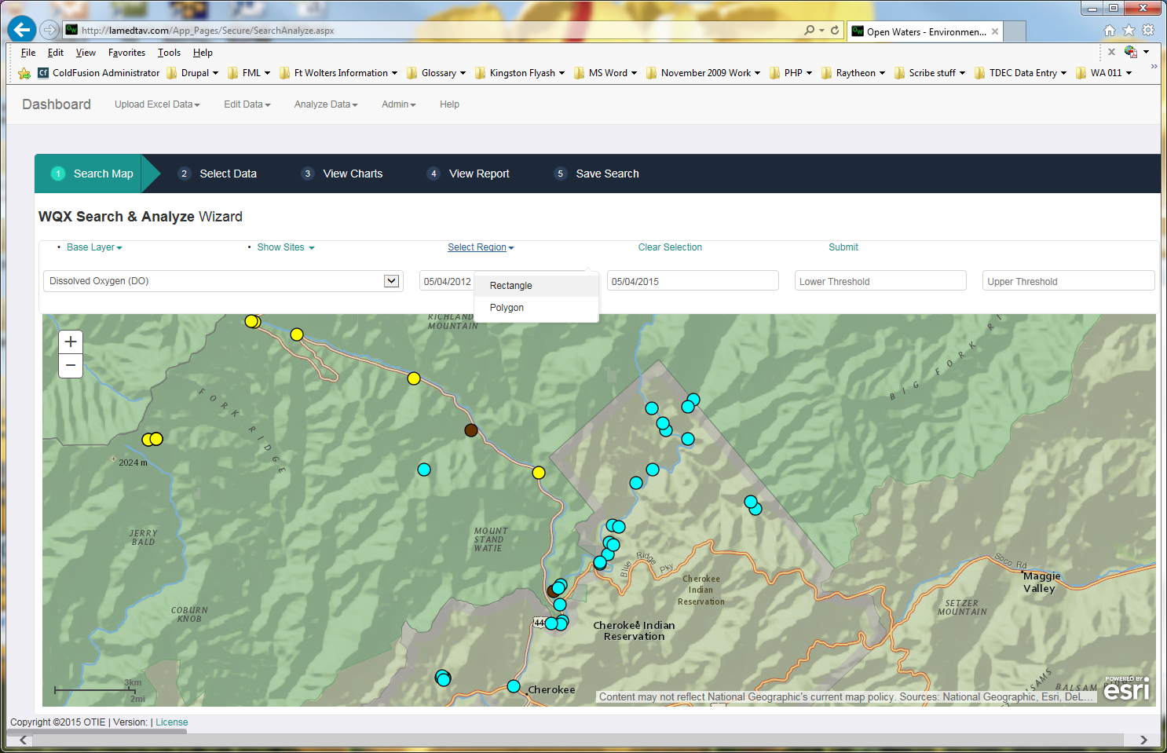

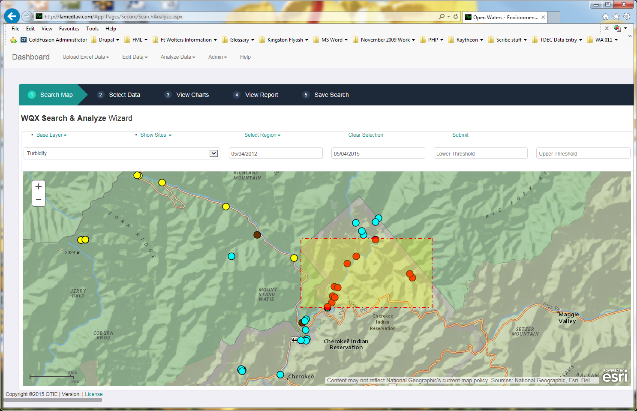

The data query may take a several seconds, and the word “**Loading**” will appear near the top of the screen. When this disappears, the data is loaded and ready to be viewed. Click on the **Select Data** menu item at the top of the page to view the data for the selected monitoring sites.

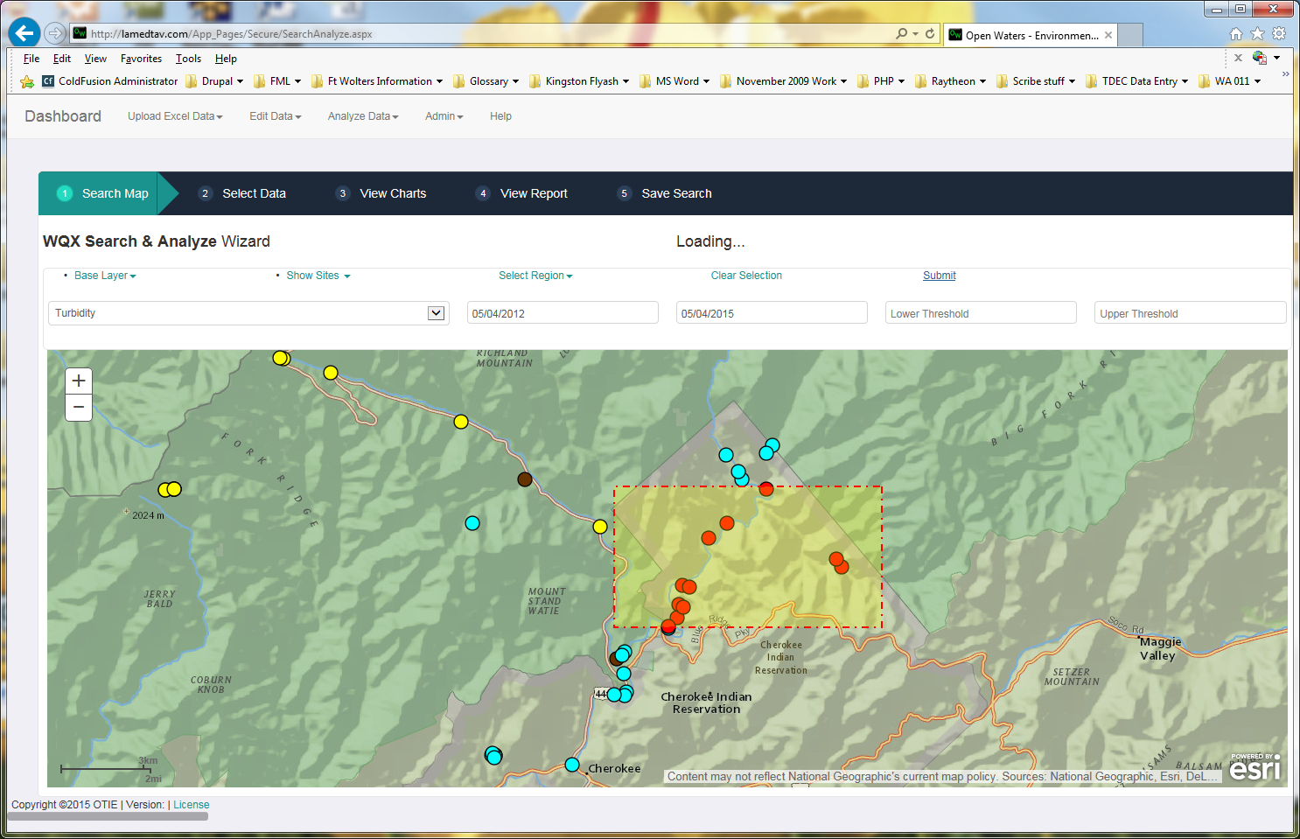

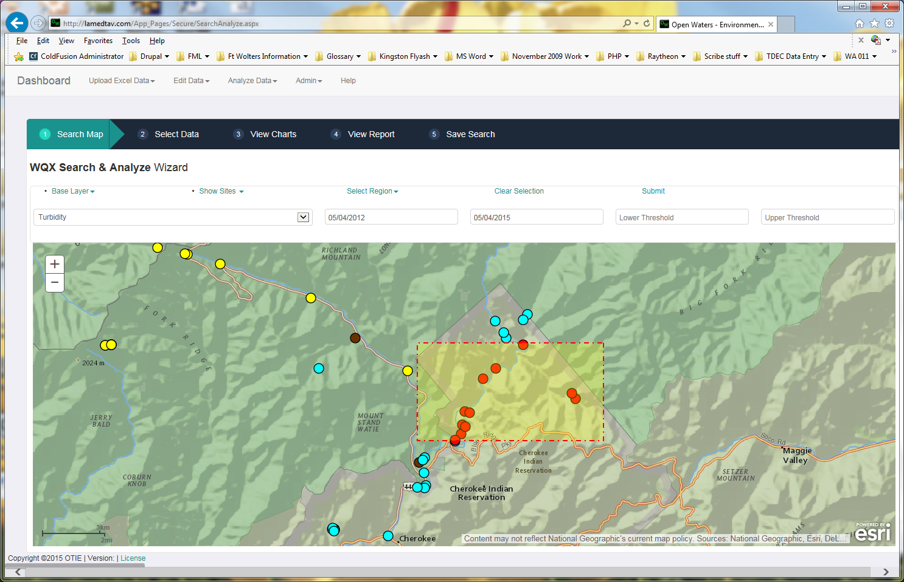

You will be shown a list of the monitoring sites located in the area you selected on the map. In order to view the data for a site, click on the site name. The data for that site will be displayed accordion-style, with the data area appearing (expanding) below the site name. You can choose to display (expand) more than one site’s data at a time by clicking on each site name.

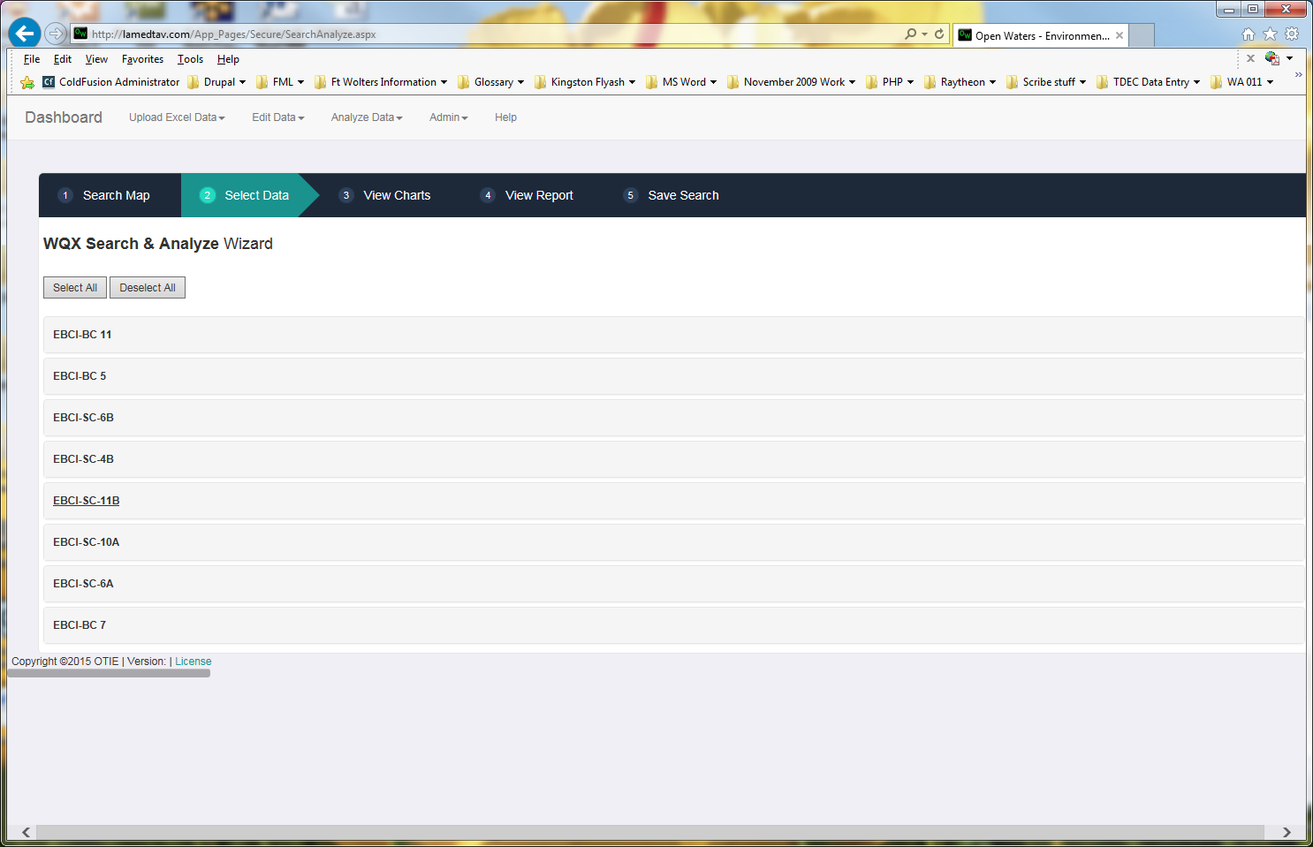

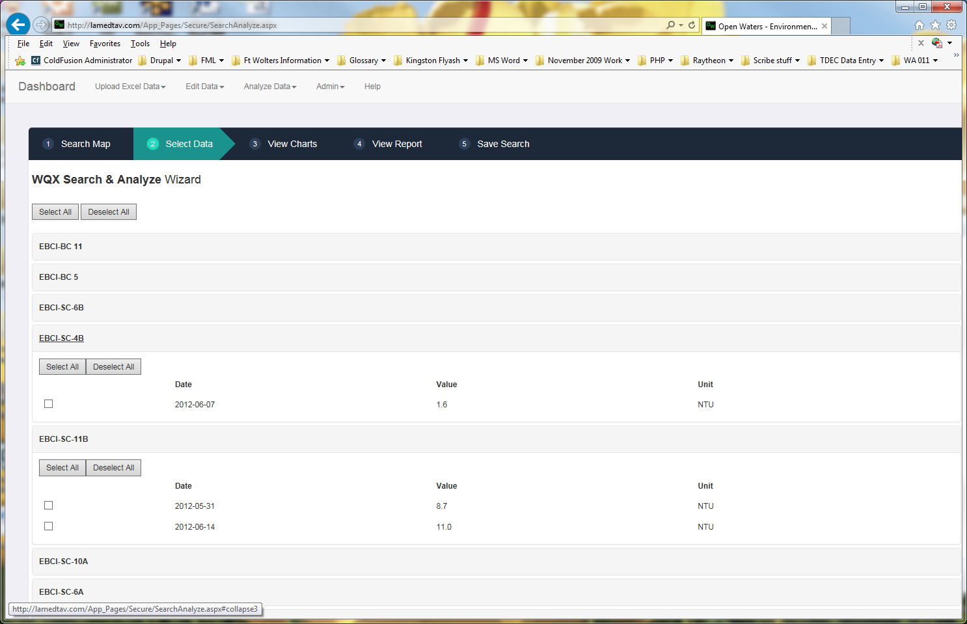

Within the data section for each of the sites, there are buttons for selecting or deselecting all of the data for that monitoring site. You may also select data points individually by clicking the checkbox next to the displayed sampling date.

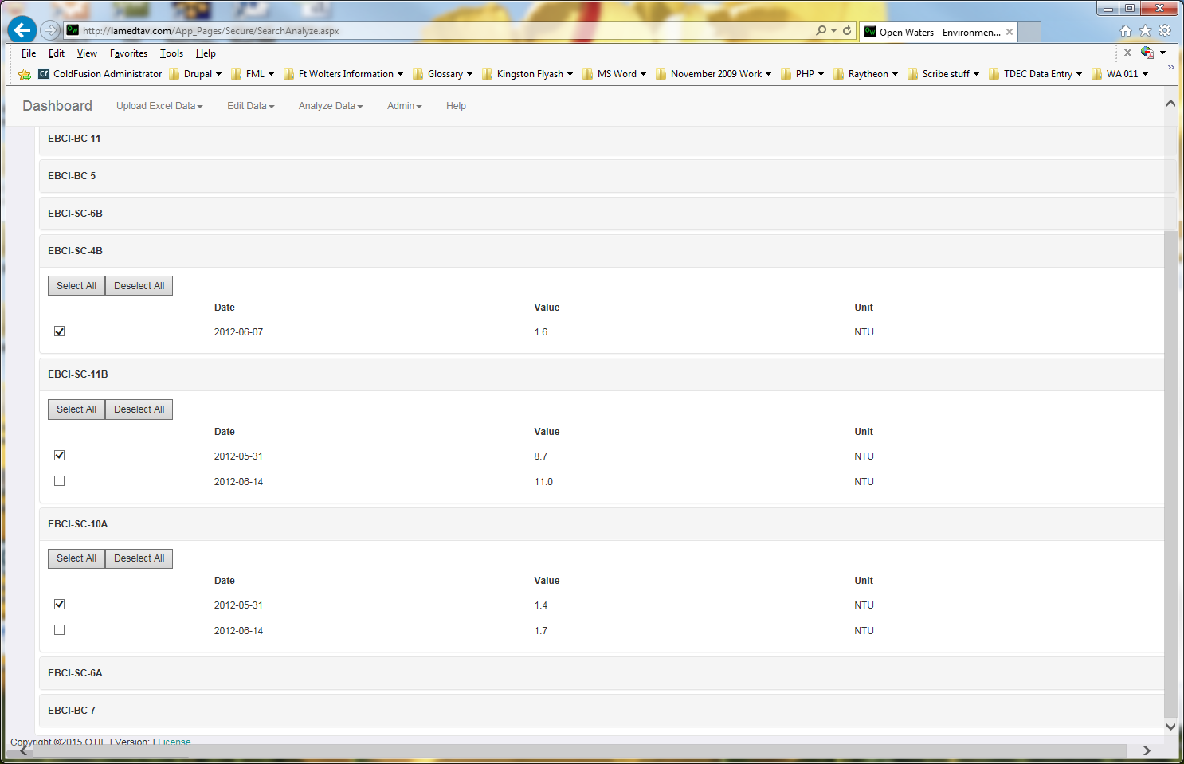

If, instead of selecting data for individual sites, you wish to select all data for all of the monitoring sites previously selected on the map, there are **Select All** and **Deselect All** buttons provided at the top of the monitoring sites list.

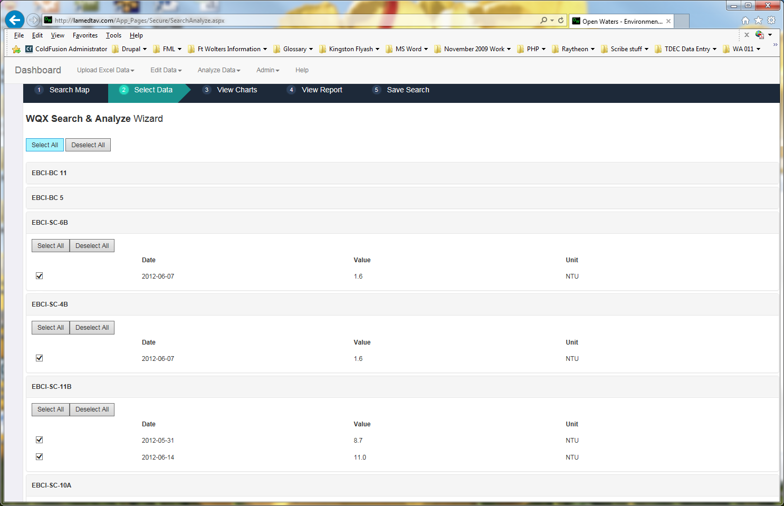

After you have selected the data you wish to analyze, click on the **View Charts** button on the top menu.

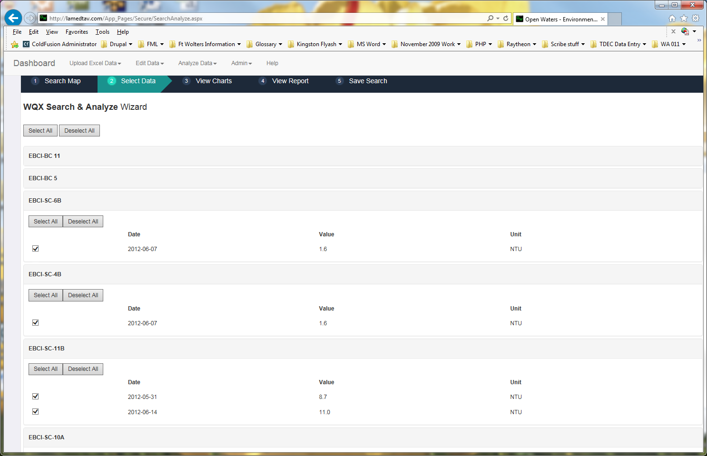

The default chart that is displayed is a Box and Whisker Plot that shows all of the data points for all of the selected monitoring sites.

The box and whisker plot groups the selected data (through their quartiles) for each monitoring location. The vertical lines extending from the boxes indicate variability outside the upper and lower quartiles. Outliers may be plotted as individual points.

If you haven’t previously entered upper and lower thresholds that you wish to be displayed on the chart, you may do so here.

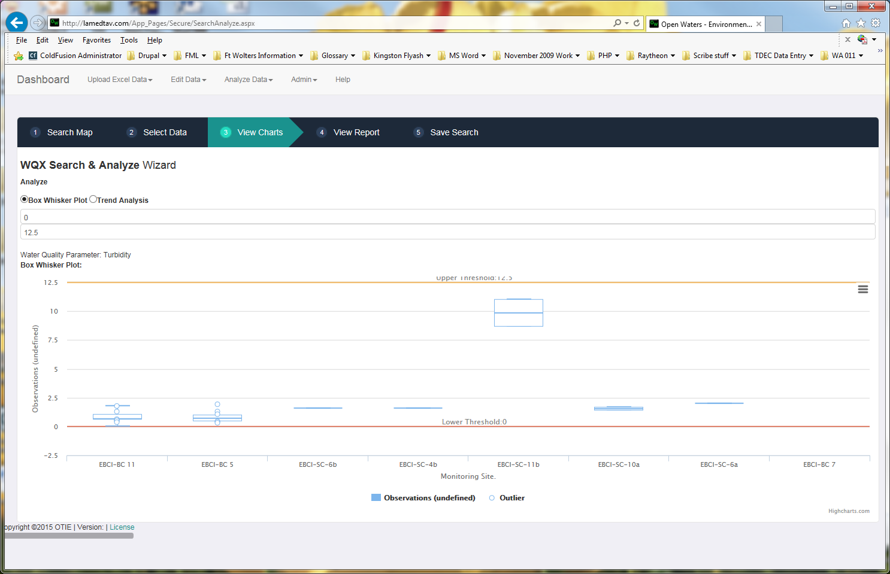

Placing your mouse cursor over the “boxes” on this chart will show you the name of the monitoring site and statistical information such as the minimum and maximum data values, the median and the upper and lower quartiles.

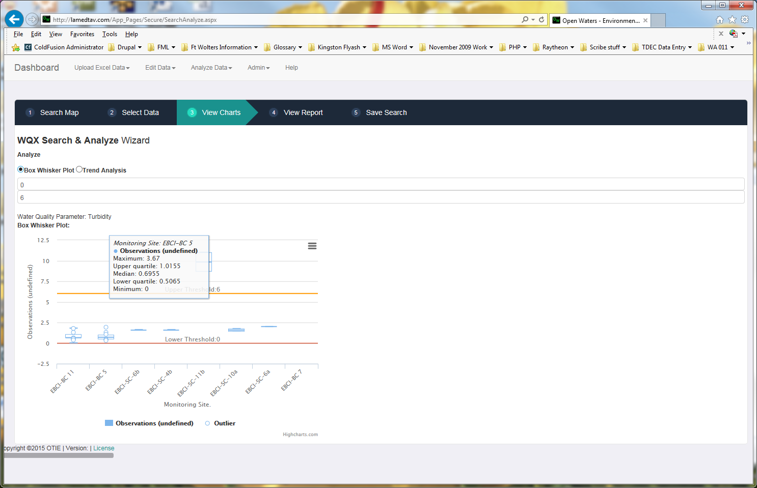

You may also click on the radio button next to **Trend Analysis** to view that type of chart.

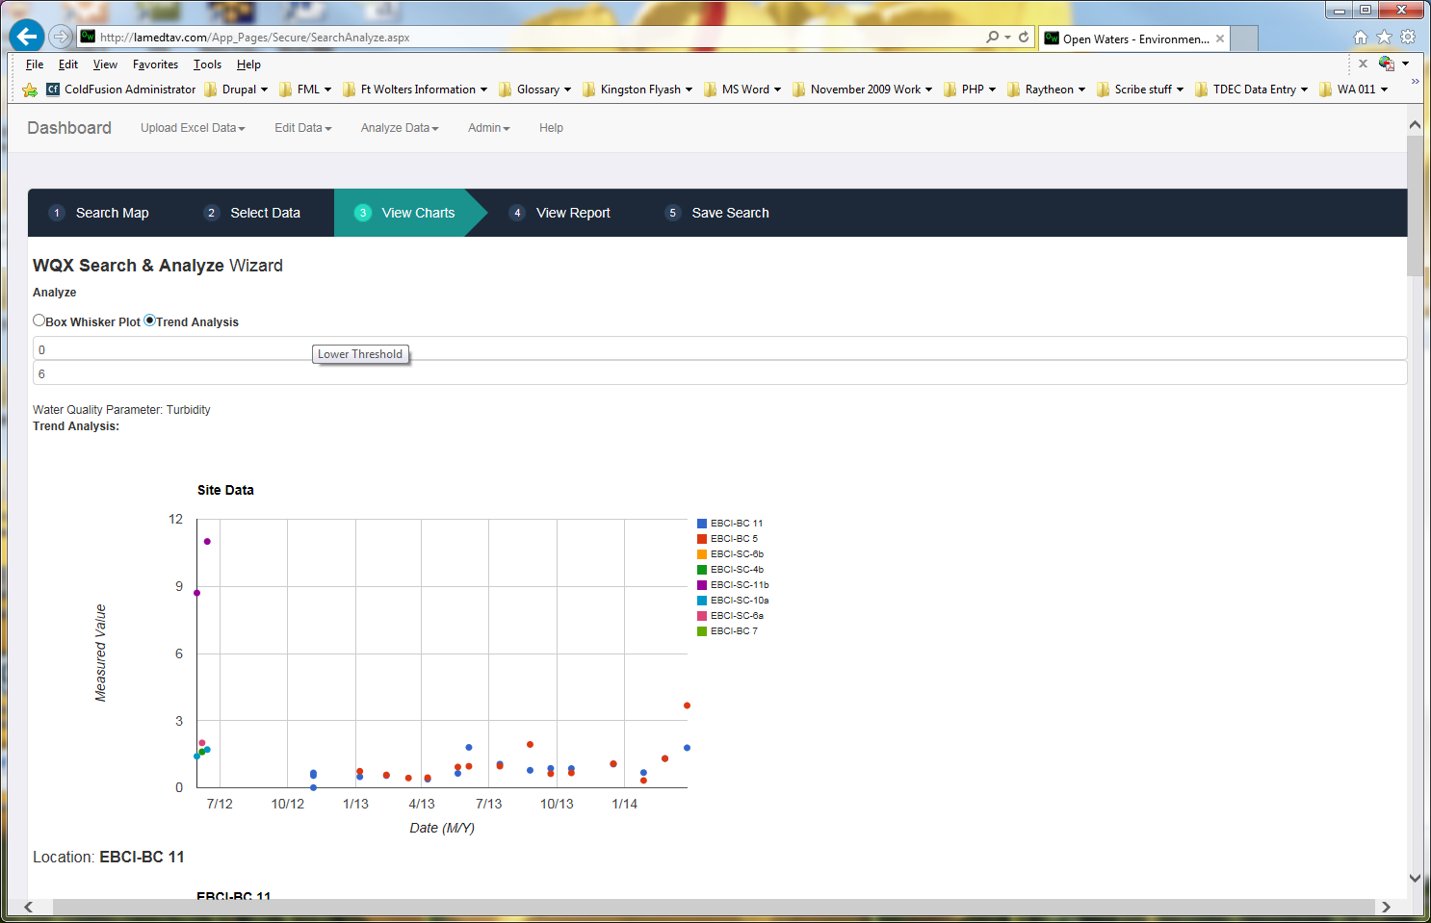

The Mann-Kendall test for trend evaluates a time-ordered data set to see if the data is following a trend and if the trend is increasing or decreasing. The more data points there are, the more likely this test will be able to identify a trend.

The first graph displayed shows the trend analysis for all data points for all of the monitoring site data selected previously. Following that are graphs for each of the individual monitoring sites.

Placing your mouse cursor over the data points on this chart will show you the name of the monitoring site, the sampling date and the data value for the water quality parameter you selected.

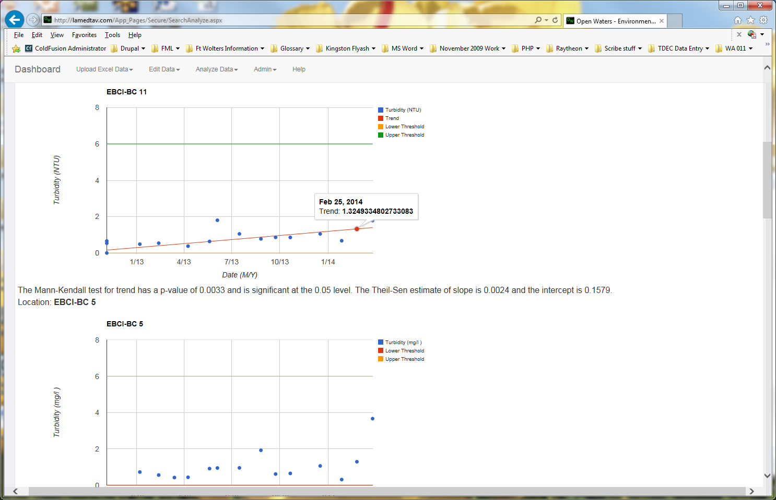

The **View Report** and **Save Search** menu items are placeholders for future development.

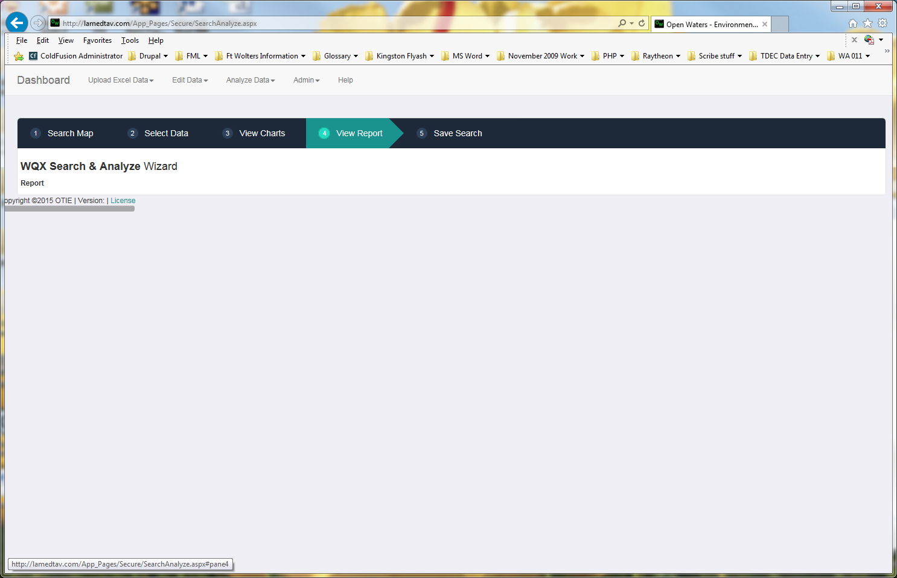

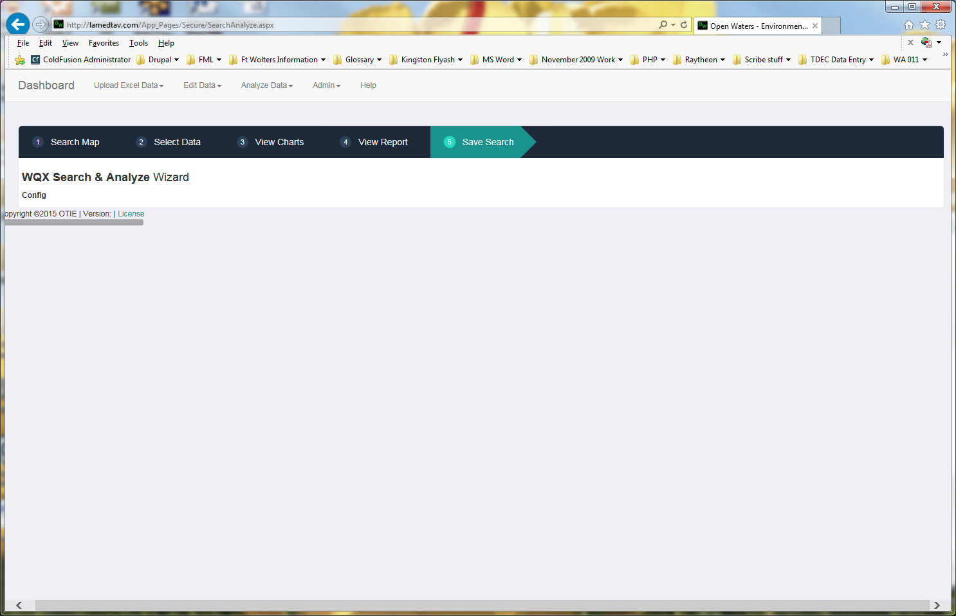

# Upload Data Section

The Upload Data section allows you to upload the results from a properly configured Excel file to the Open Waters database and ultimately to the Water Quality Exchange portal (WQX). This requires that all of the following data items be manually setup prior to uploading the file:

* Organization
* Project
* Monitoring Location(s)

The file requires the following fields:

* Monitoring Location Name (as setup in advance)
* Activity Date
* Activity Time
* Sample Collection
* A column for each result to be loaded into the database.

The overall process for loading a MS Excel file into the database is as follows (each of these steps will be shown in further detail in subsequent screenshots and text:

1. Manually load the required data in the database.
2. Load the desired MS Excel file into the system. At this point, no data is saved to the database. You will see the top portion of the file in the site for your reference. Clicking upload data will provide a form to upload a file and a link to a sample file.
3. Setup the file configuration. This tells the system what labels you are using for the system’s fields.
4. Select the Project this data belongs to.
5. Migrate the data to the database. All rows will be loaded until the first row with a blank value in the 1st column in encountered.

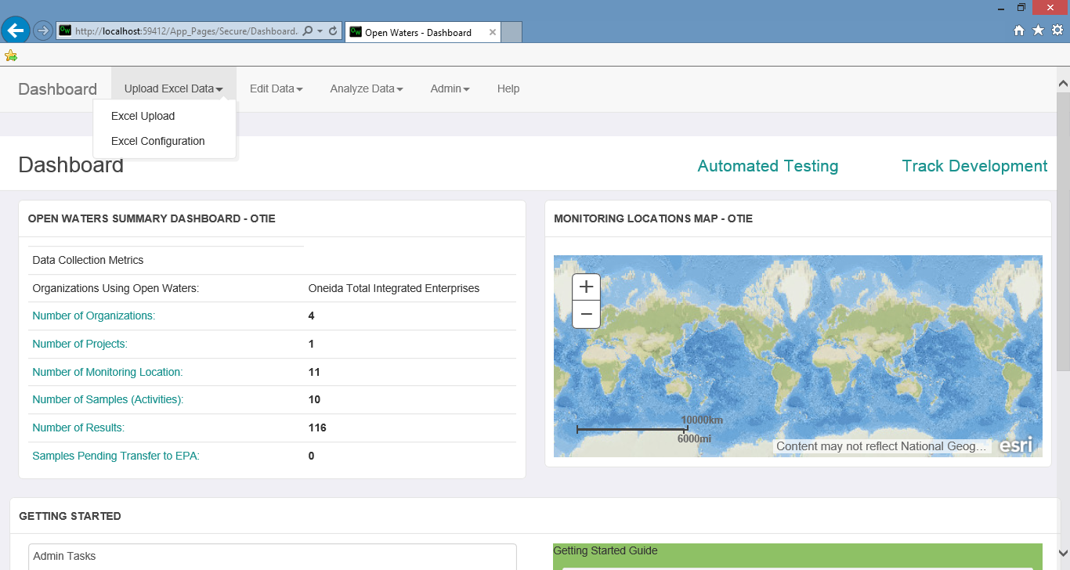

Figure 1: Launch Excel Upload

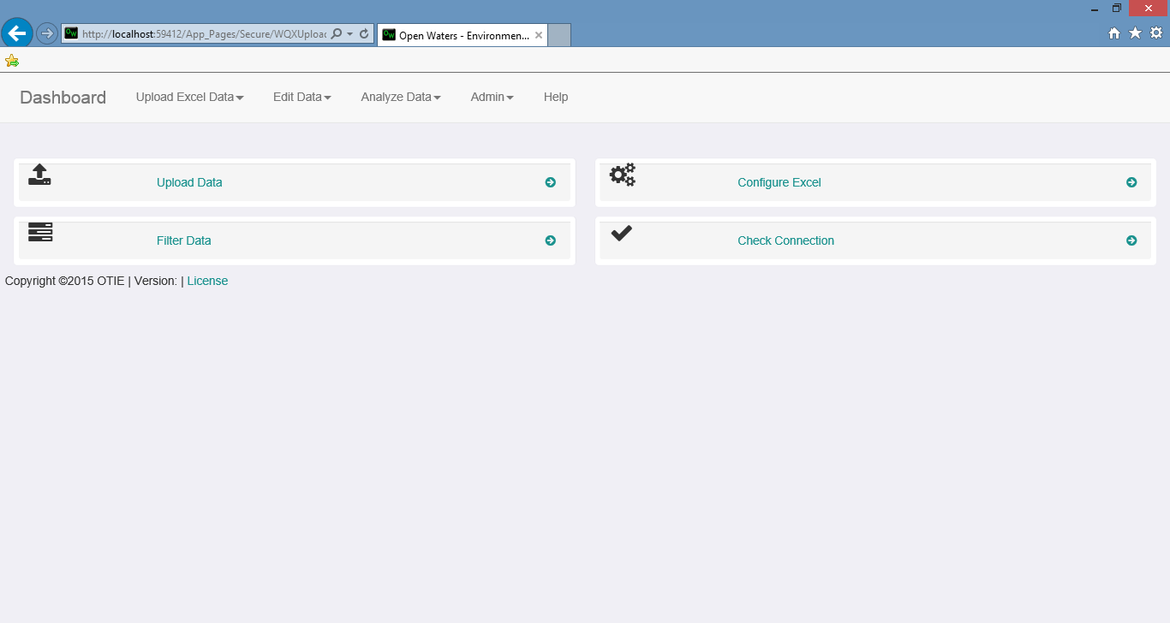

Figure 2: Click Upload Data

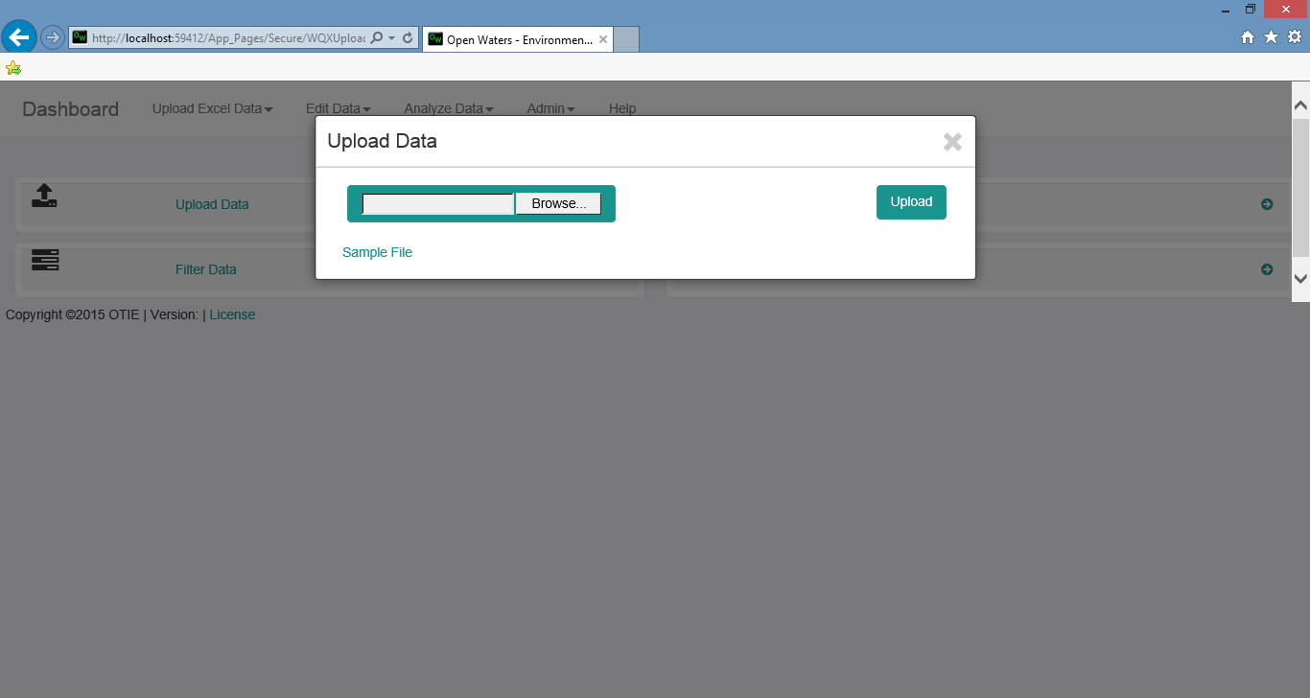

Figure 3: Select the file to upload

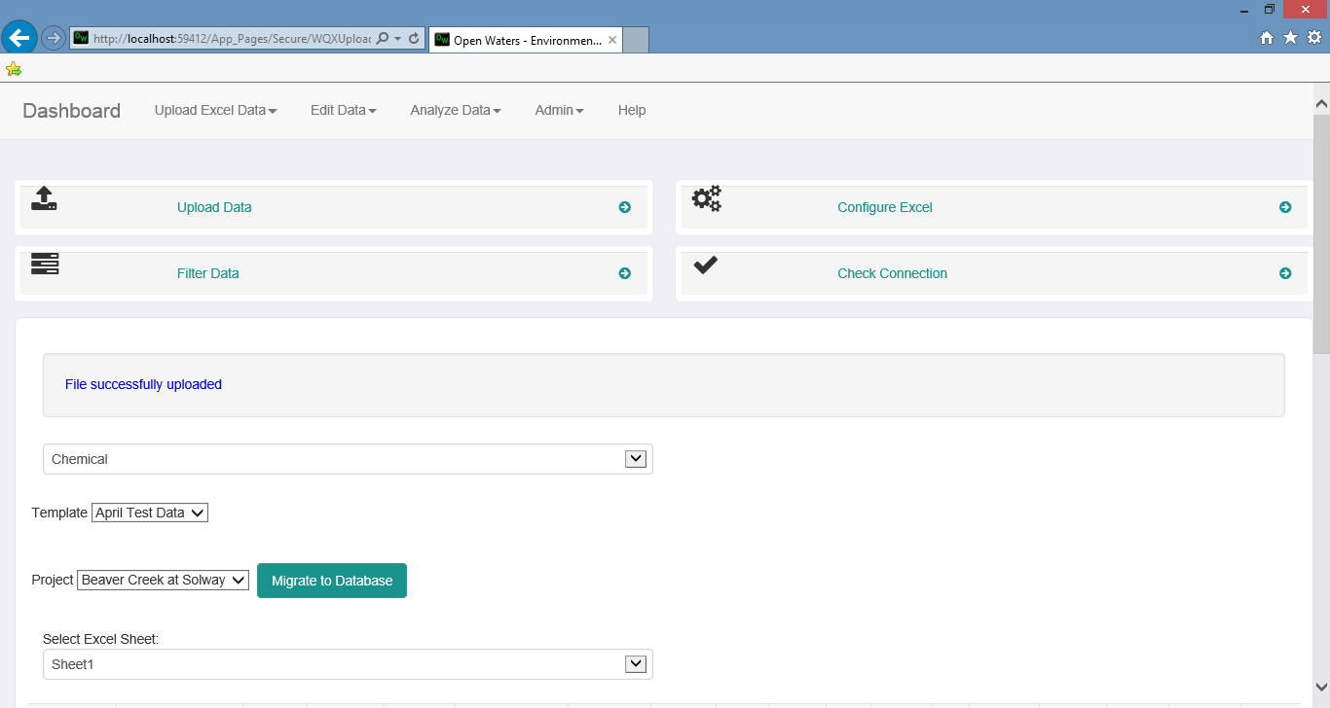

Figure 4: Click Migrate to Database

## Configure Upload

Prior to migrating a set of data to the database, you will need to configure the file format. The system will provide a list of fields to choose from. The process for configuring a file format is:

1. Upload a sample file into the system and click **Configure Excel**. All column headings in the file will be listed.
2. Select the Database field that the field in the file should be mapped to. If the field is a Characteristic, select the appropriate Characteristic.
3. Click **Submit**.

 Figure 5: Click Configure Excel

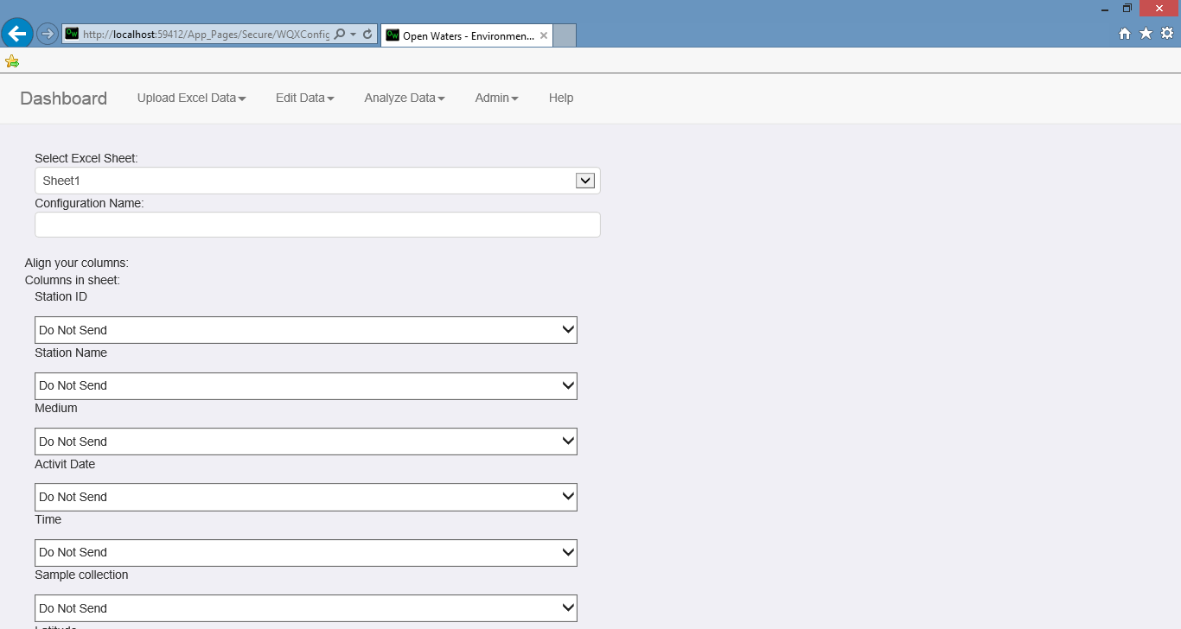

Figure 6: Select which fields should be mapped to what in the Database

## Configure Possible Fields For MS Excel File Uploads

The choices in the Configure Excel field can be modified. This allows you to control what fields are available for configuring an upload file. Since the total number of characteristics is very large, this allows you to make the **Configure Excel** form easier to use for your users. Additionally, you can add Max and Min values to Characteristics that the uploaded value will have to fall between. The process is as follows:

1. Select **Column Admin** from the **Admin** menu
2. Click **Add a Column Configuration** to add a new column
3. Enter the **Column Name**, **Unit for this Characteristic**, **Max Value**, **Min Value** and choose if this value should be sent to WQX (this feature is not fully available)
4. Click **Save and Exit**

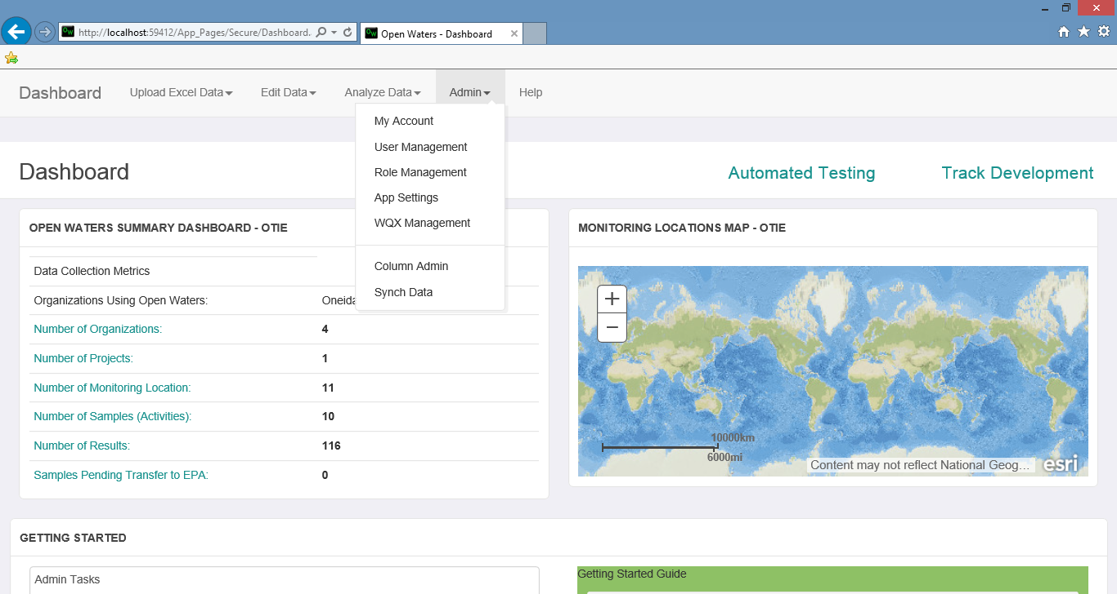

Figure 7: Click Column Admin

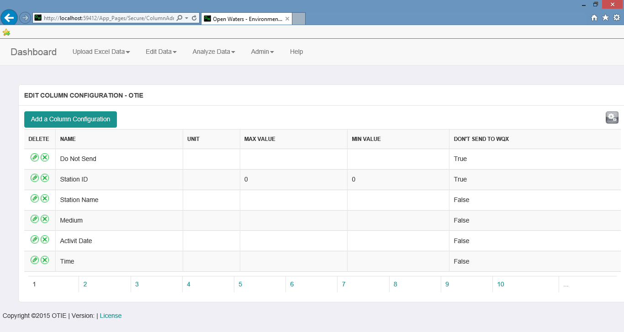

Figure 8: Click Add a Column Configuration

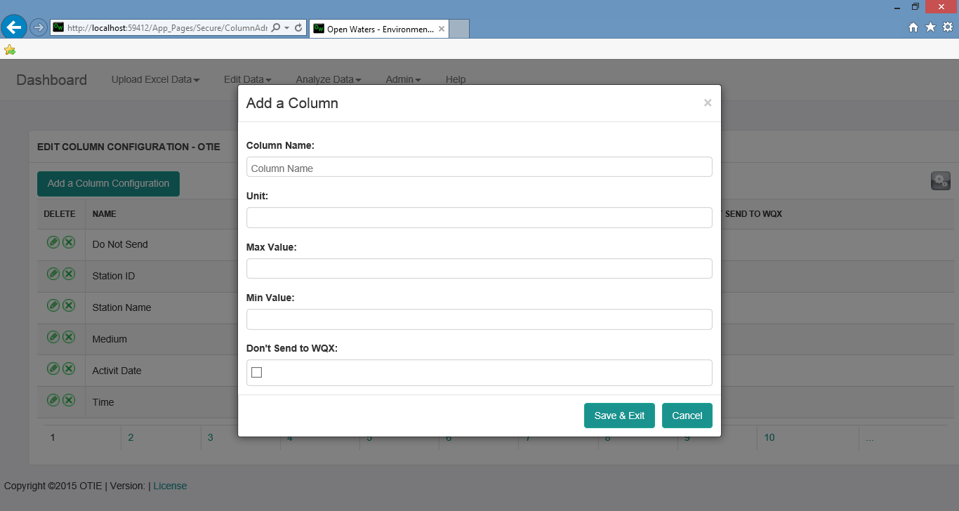

Figure 9: Enter Data and Save

# Manual Data Entry

## Organization

Organizations represent the highest level of data being loaded in the system. All other data will be related to an organization. The **Organization Info** page allows you to Add and Edit organizations. Once an organization is added, it cannot be deleted. The fields available are:

* Organization ID
* Organization Name
* Description
* Tribal Code
* Email
* Phone
* Phone Extensions
* Credentials for submitting to WQX

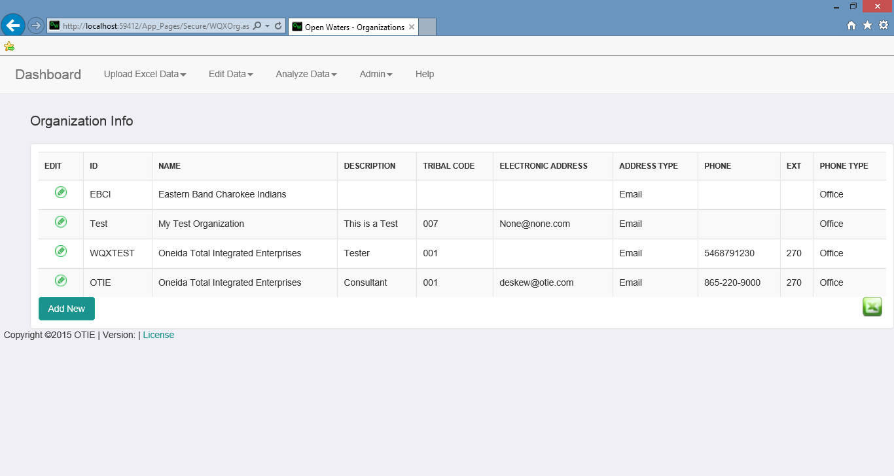

Figure 10: List of all Organizations available to the user.

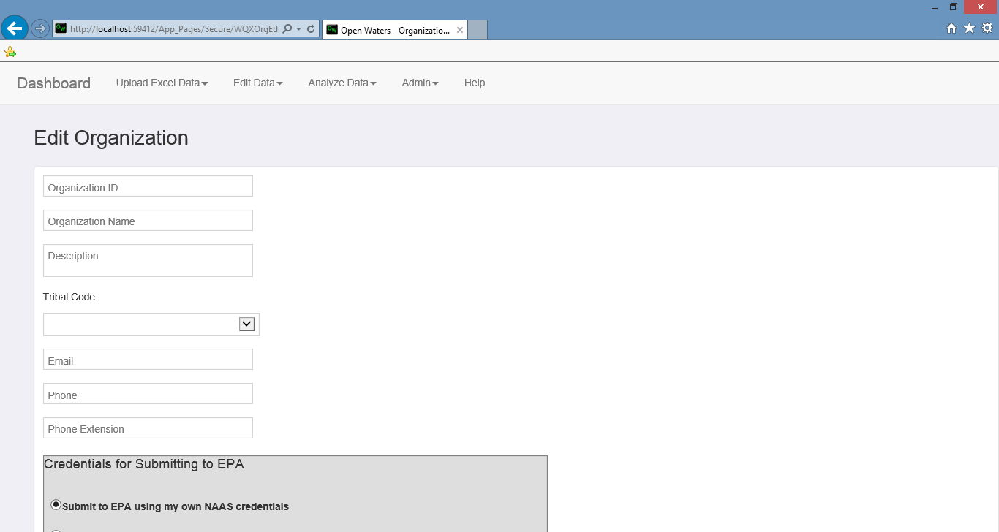

Figure 11: New/Edit Organization Screen

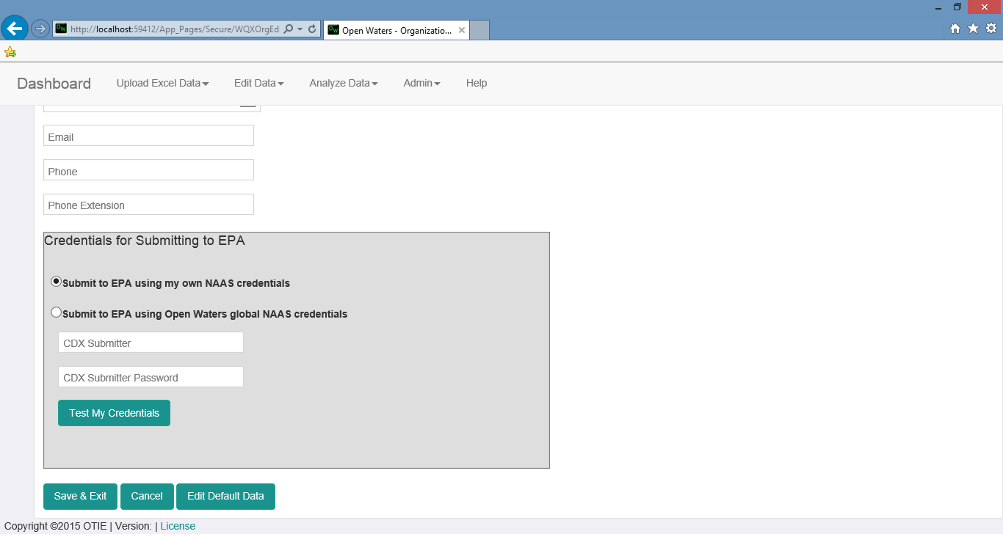

Figure 12: New/Edit Organization Screen cont.

## Projects

Projects represent a collection of data to be submitted. A single project can be associated with one or more sets of results but a single set of results can only be associated to a one project. The Projects page allows you to Add and Edit projects. Once saved, a project cannot be deleted but can be inactivated. The following fields are available:

* Project Name
* Project Description
* Sampling Design Type
* QAPP Approved
* Approval Agency
* Active
* Send to EPA

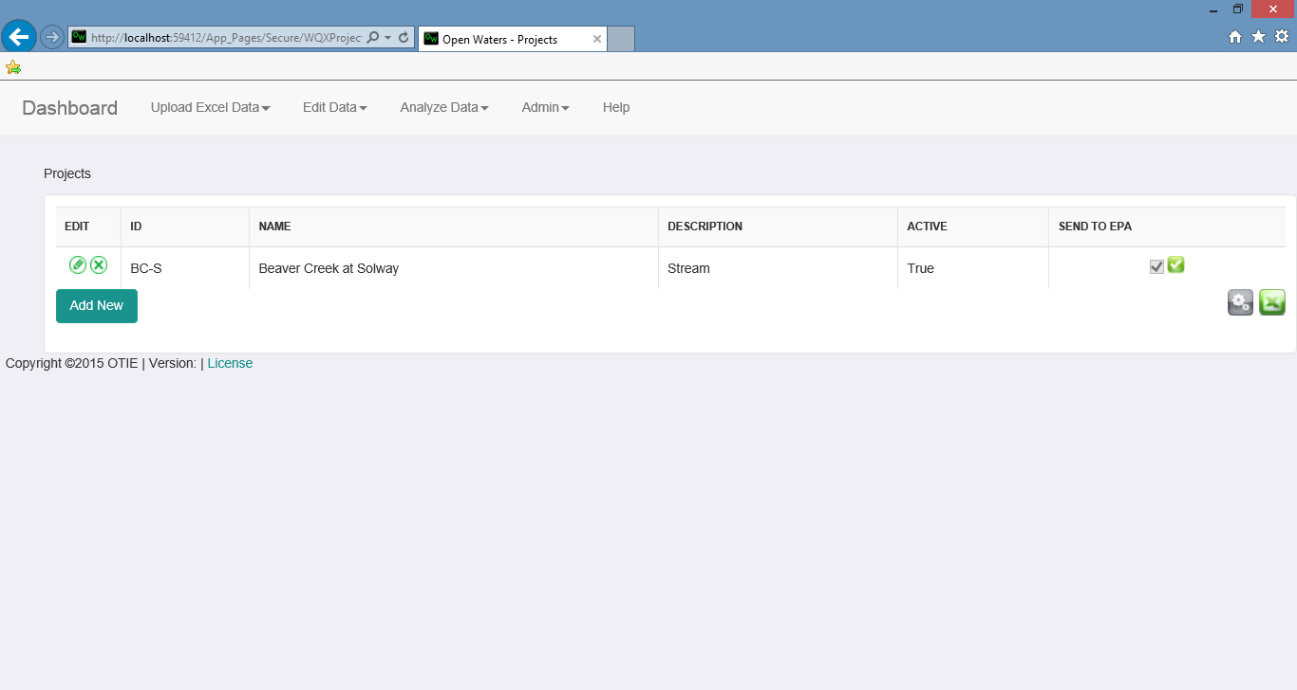

Figure 13: List of all projects available to the user

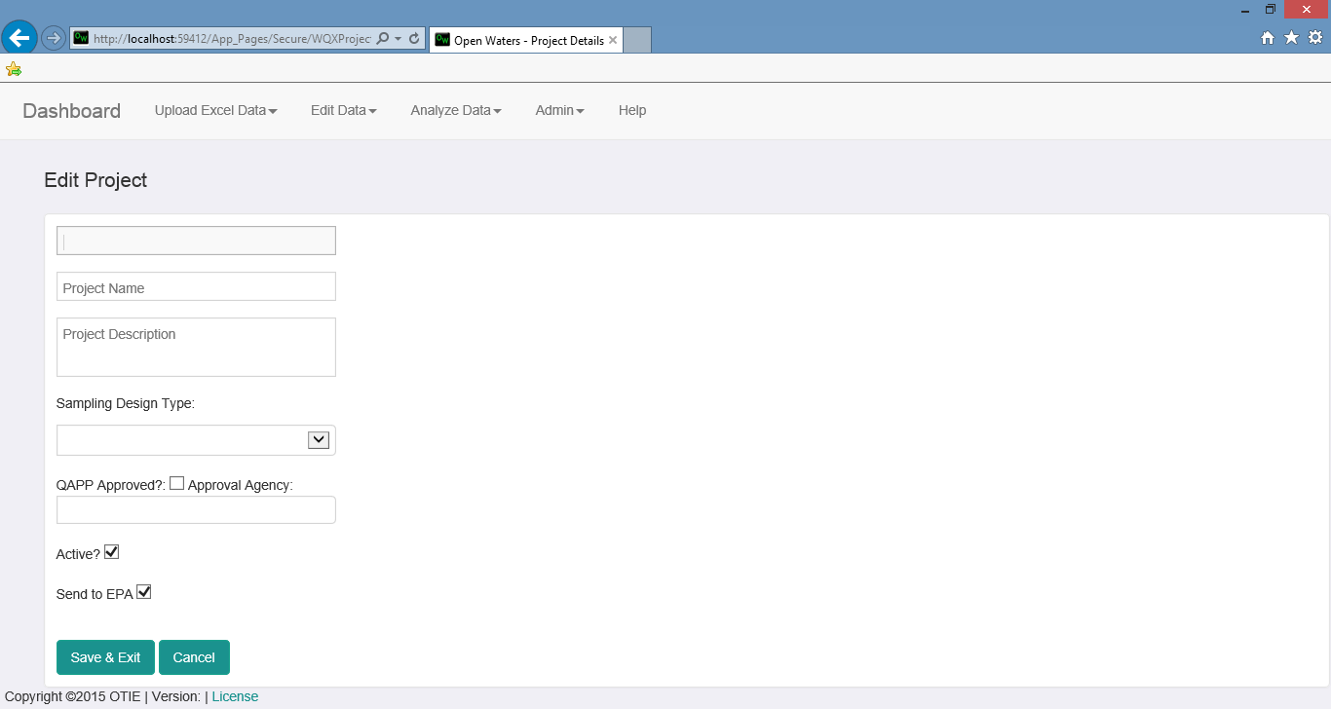

Figure 14: New/Edit Project Screen

## Monitoring Locations

Monitoring Locations are the locations where a sample is collected. A monitoring location can be deleted but the data associated with it will not be removed from the database. It will still be available but will no longer be displayed by default. The fields for a monitoring location are:

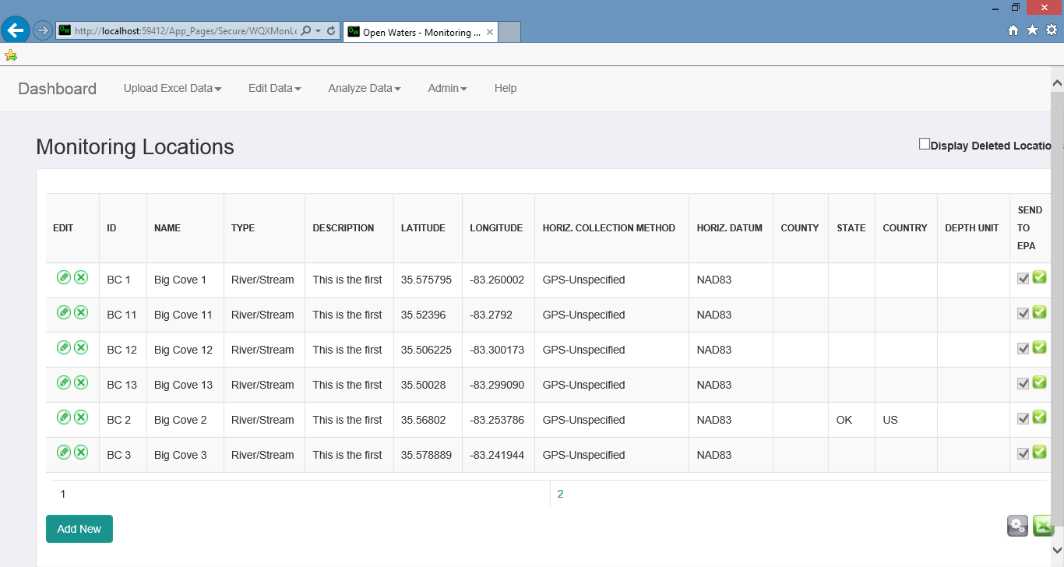

Figure 15: List of all monitoring locations available to the user

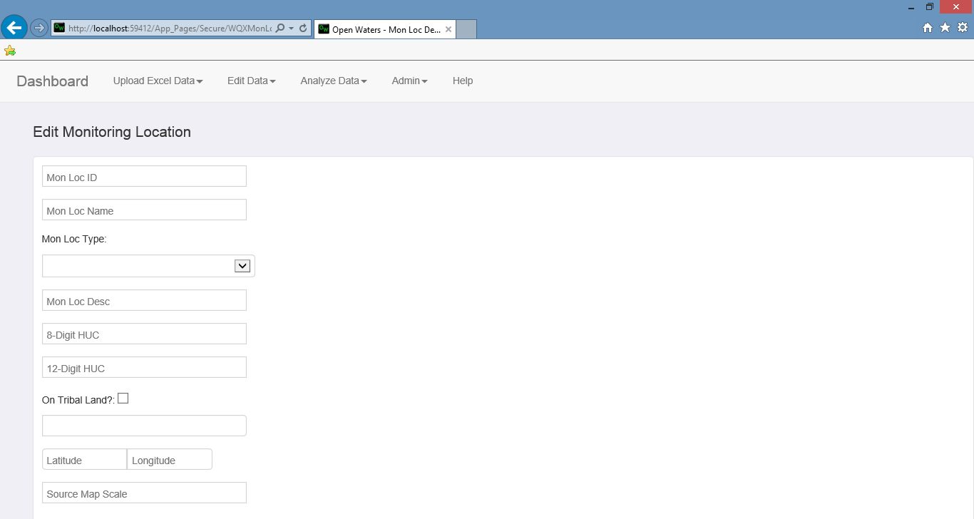

Figure 16: New/Edit Monitoring Location screen

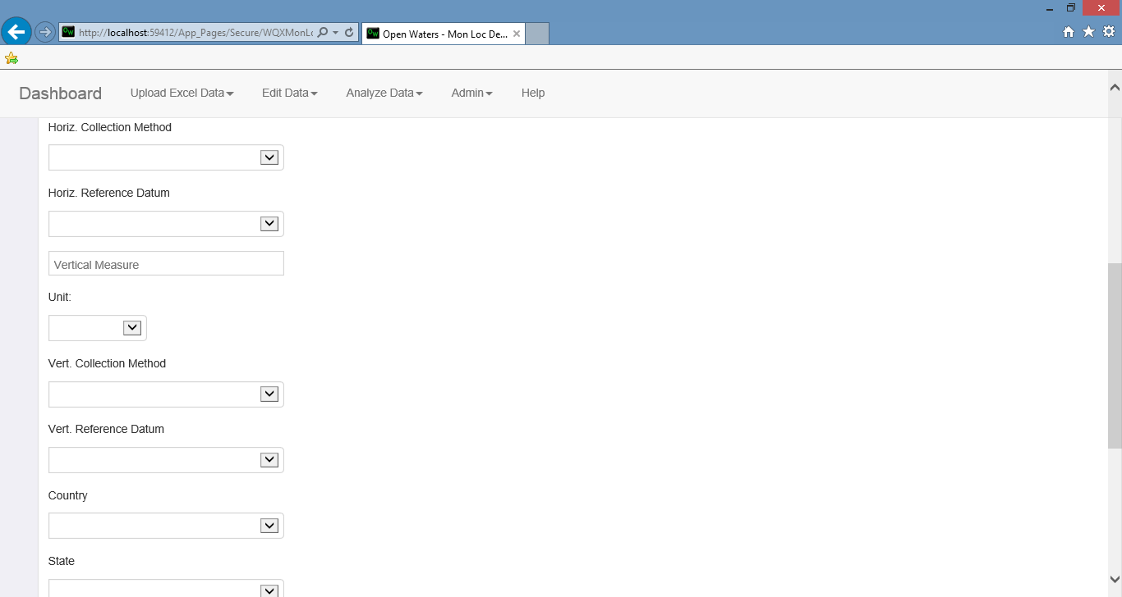

Figure 17: New/Edit Monitoring Location screen cont.

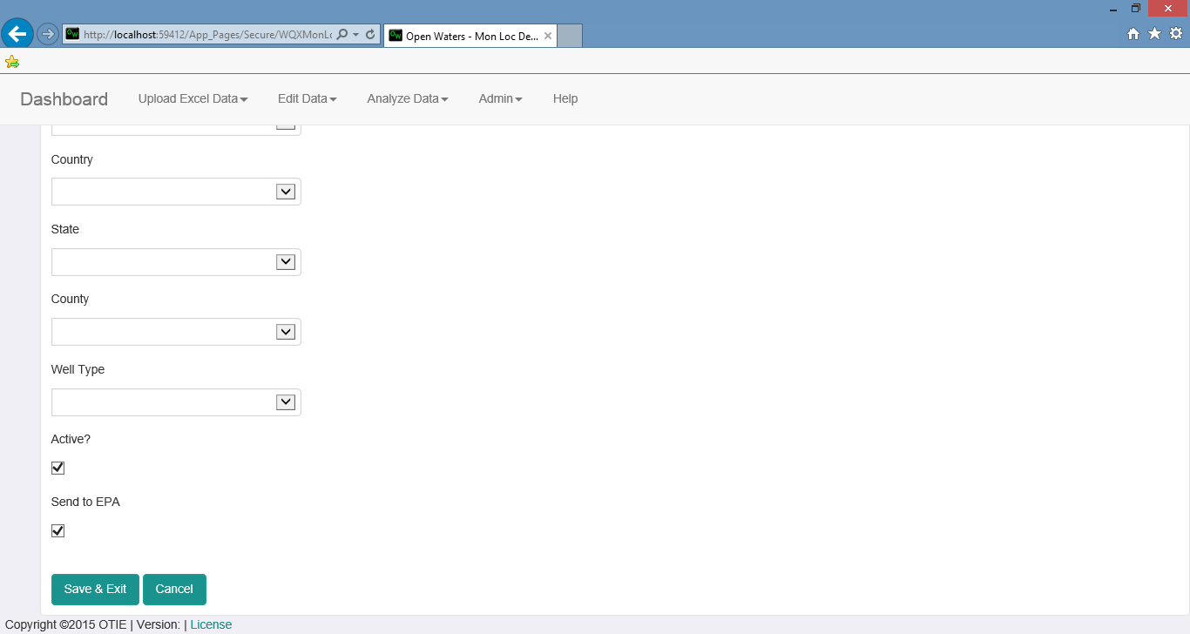

Figure 18: New/Edit Monitoring Location screen cont.

## Activities

Activities are actual results collected from a monitoring location and analyzed. Activities are tied to a monitoring location and to a project. Like a monitoring location, an activity can be deleted but the data is not removed from the database. The activity screen has the following fields that can be used as filters to more easily find desired activities:

* Monitoring Location
* Activity Type
* Date Range
* Project
* Deleted Activities (this includes deleted activities when checked)

When adding a new activity, the following fields are available for entry:

* Activity ID. This is auto generated but can be modified.
* Activity Date/Time
* Time Zone
* Monitoring Location
* Project
* Activity Type
* Activity End Date
* Activity Media
* Activity Depth
* Activity Submedia
* Activity Comments
* Collection Duration
* Sampling Component
* Components Sequence
* Result Type

Once an activity has been created, one or more results can be added to the activity. To edit an existing result, click on any of the values for that result and the row will become editable. To add a new result, use the fields at the bottom of the page. Deleting a result will permanently delete the result from the database. The following fields are available for entry:

* Characteristic. This is a list of characteristics setup for use with the user’s current org.
* Result
* Unit
* Detection Limit
* Analytical Method
* Samp Fraction
* Lab Analysis Date
* PQL
* Lower Quant Limit
* Upper Quant Limit
* Comment

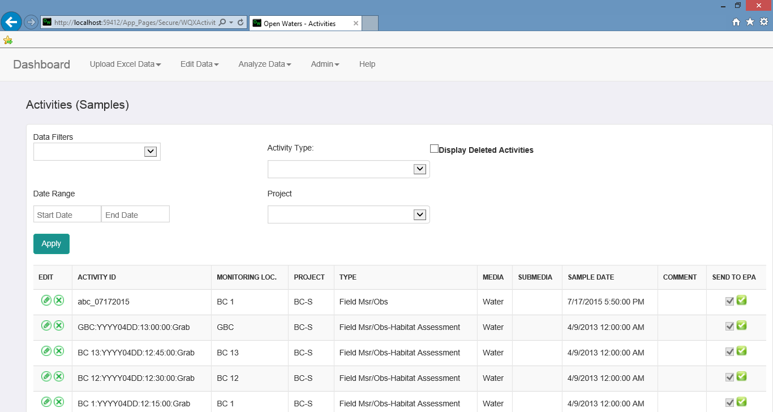

Figure 19: List of all Activities available for the user

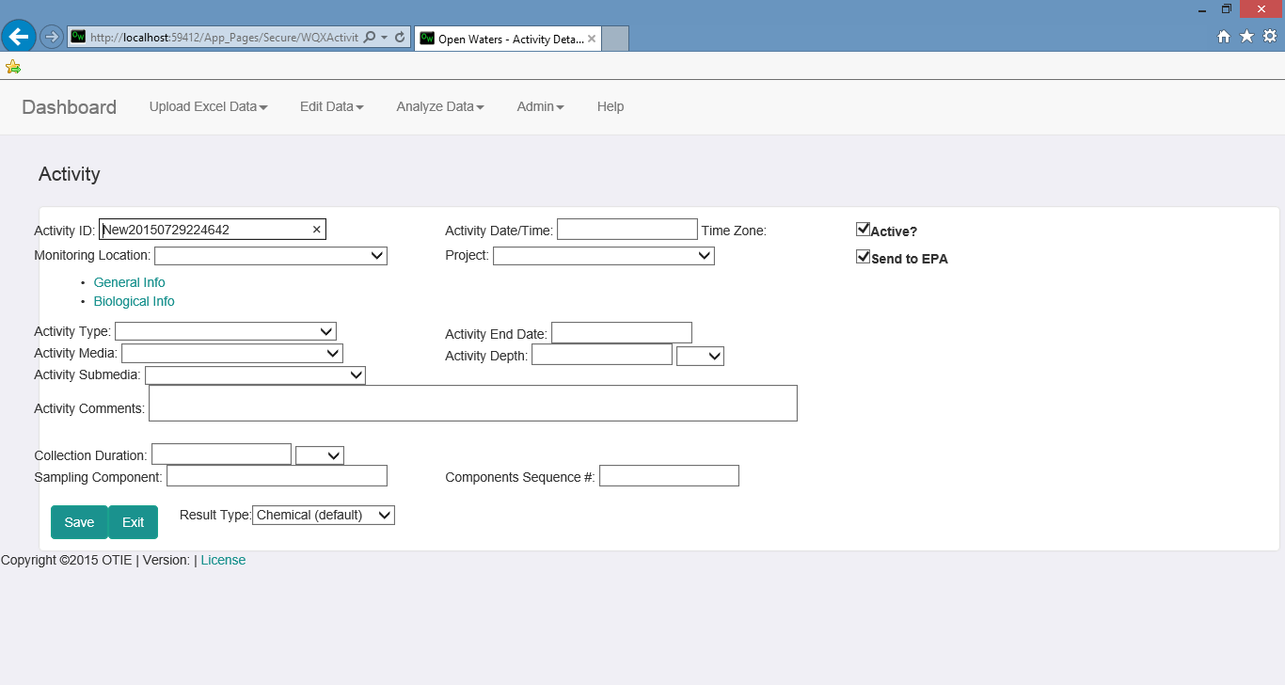

Figure 20: New/Edit Activity screen

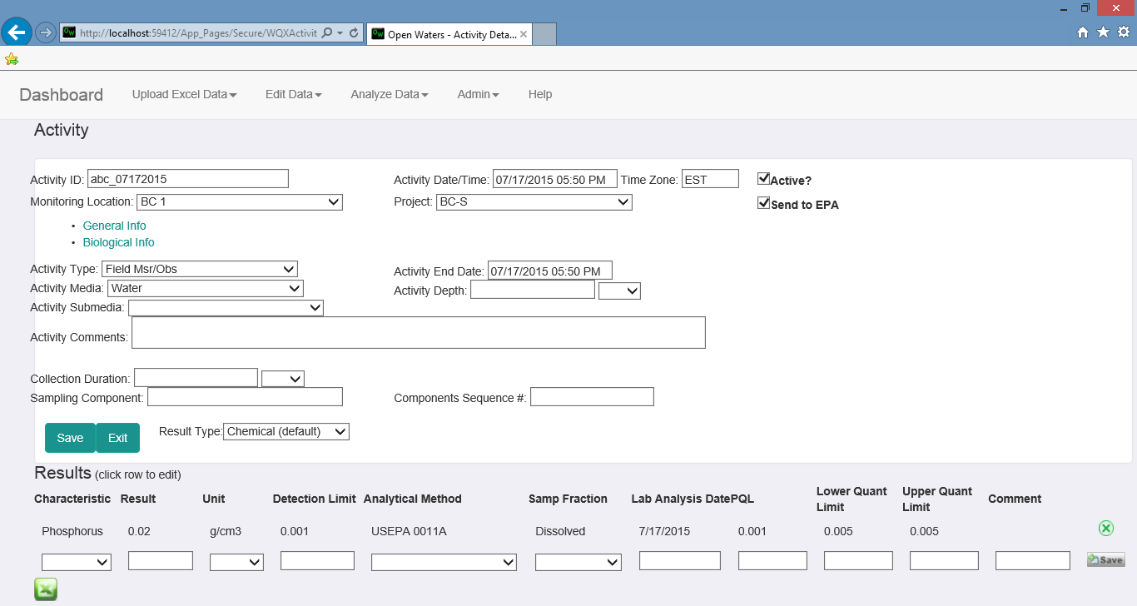

Figure 21: Activity Results add/edit screen

## Analyze Configuration

Do we need this section? I am not sure Mike implemented it.

# Administration Section

## My Account

**My Account** allows you to change the user information associated with your account. This also allows you to see your roles and your organizations. The fields that can be changed are:

* First name
* Last name
* Email
* Phone number

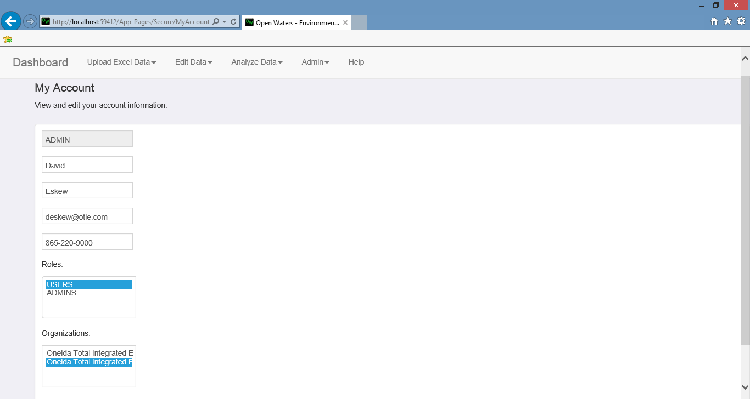

Figure 22: My Account screen

## User Management

Steps for a adding a new user:

1. Add new user
2. Add a role
3. Add an organization

## Role Management

Role Management is used to configure which users get which roles. There are 3 roles in the system.

* Users – Users can manually load data into the system or upload data via the Excel Upload feature. Additionally, Users can make use of the Search and Analyze functionality.
* Admins – Admins have full access to create users, add or update data and submit data to the WQX portal.
* Read Only – Read Only allows user to view data in the system but not add or modify the data.

To add or remove a role from a user, follow these steps:

1. Click Admin > Role Management
2. Click the Edit icon next to the role you wish to add or remove from the user(s).
3. Select the user(s) you wish to add the role to from the Available Users box or from the Users in Role box. You can select multiple users by holding down the ctrl key while clicking on them.
4. Click the middle button that moves the user(s) to the correct spot. This would be Add User to Role or Remove User from Role.
5. Click Save.

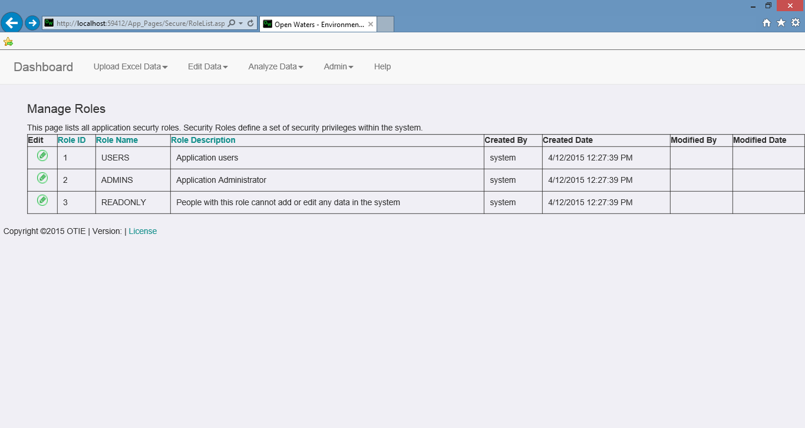

Figure 23: Manage Roles screen

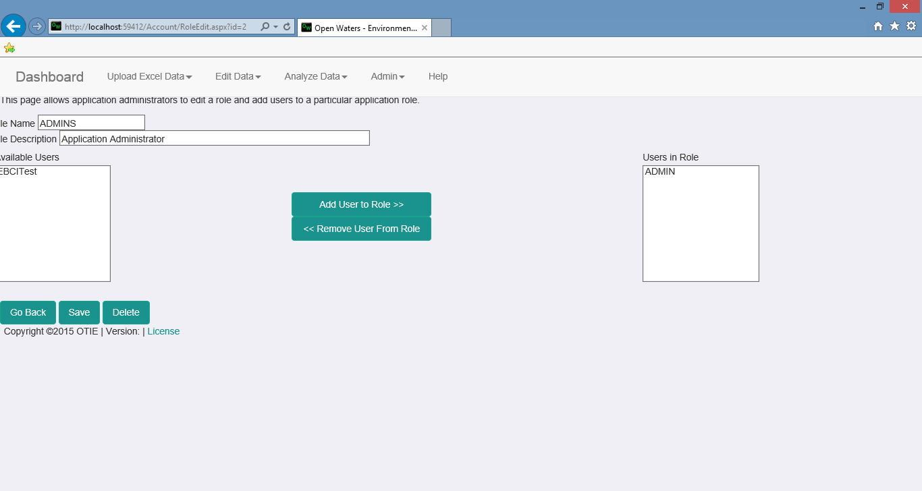

Figure 24: Edit users having role.

## App Settings

App Settings allows you to modify the application’s settings. These include the application path for the public, submission settings for WQX and email settings. These should only be changed by appropriate administrator.

To change a setting:

1. Click Admin>App Settings.
2. Click Edit next to the setting to be changed.
3. Update the value. The Name and ID should not need to be changed.
4. Click Update

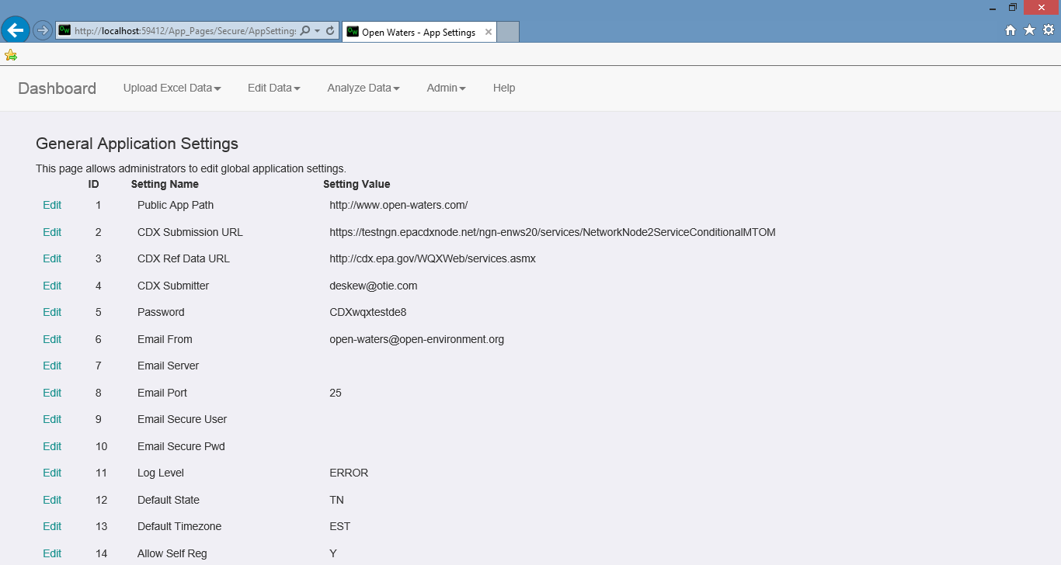

Figure 25: Application Settings screen

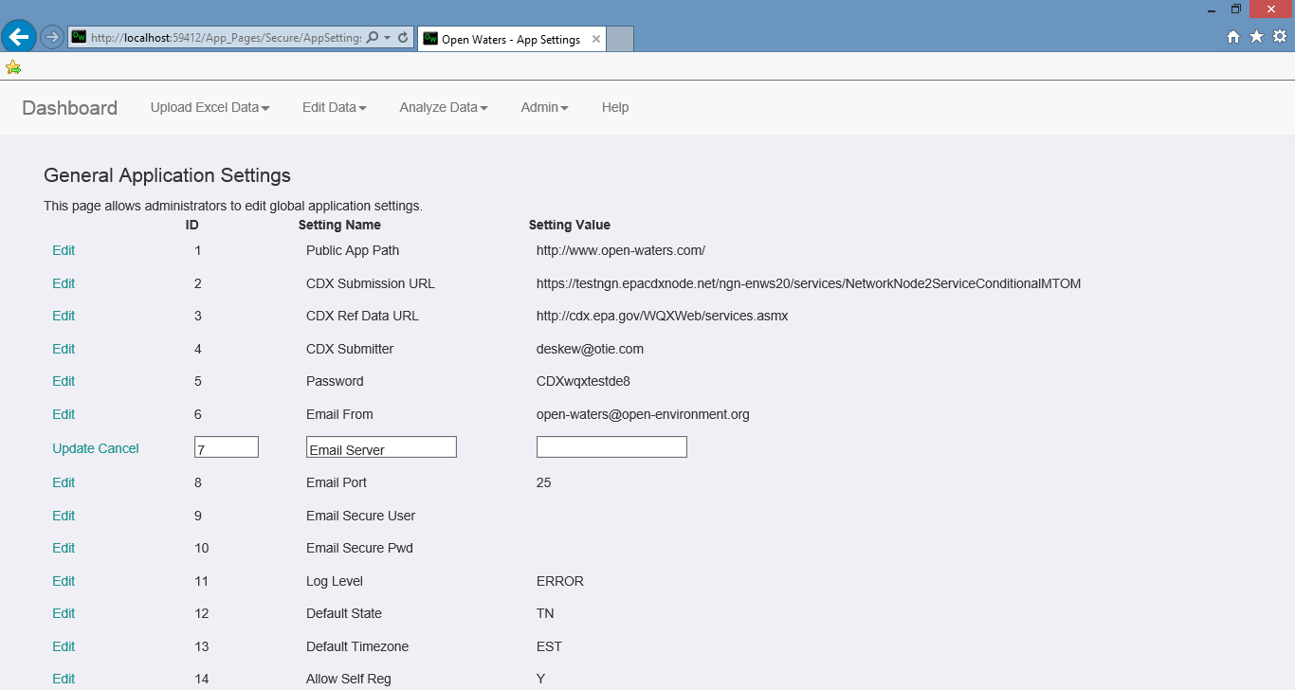

Figure 26: Application Settings Edit Screen

## WQX Management

WQX Management screen allows an administrator to submit records to WQX and check on the status of previously submitted records. If the submit service becomes stuck, it also allows you to reset the service. When you start the submission, you should wait for it to complete to ensure you get your results back. This may take a long time. If the service is interrupted, click Reset Service to enable it to be run again.

Listed at the bottom of the page is all of the previous submissions that have completed. They will have a status of Completed meaning the WQX portal received and recorded the data or Failed meaning the WQX portal was not able to record the data. Clicking the View File link will allow you to download the XML file returned from the WQX portal which will contain any error messages explaining why the submission failed.

Select Submit As Individual Records to submit each record individually. Alternately, you can select Submit As One File to have all records submitted in a single batch. The Submit As Individual Records can be used to troubleshoot data errors.

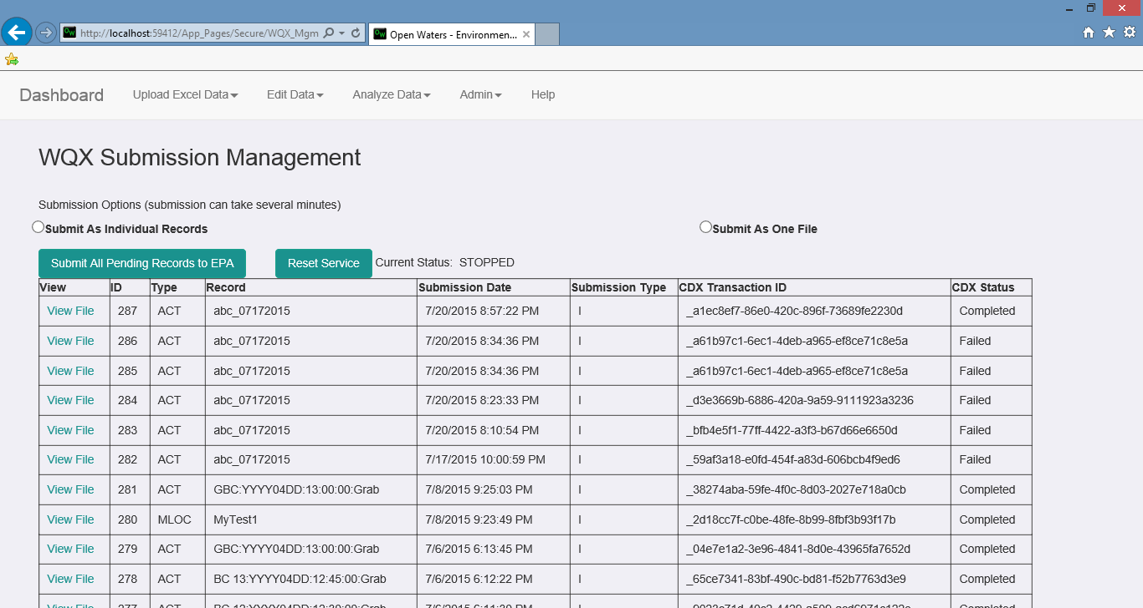

Figure 27: WQX Submission Screen

## Org Characteristic Settings

Org Characteristic Settings are used to select which Characteristics an organization can record data for. This is only used for manually entered data, not for data being uploaded via spreadsheet.

The process for adding a Characteristic to an Org is:

1. Click Admin >Org Characteristic Settings
2. Choose Edit Characteristics List radio button. This will automatically update the screen to provide a list of all current Characteristics for this org and a drop down to add a new Characteristic.
3. Select the desired characteristic from the drop down and click Add Characteristic to add that characteristic to the org.

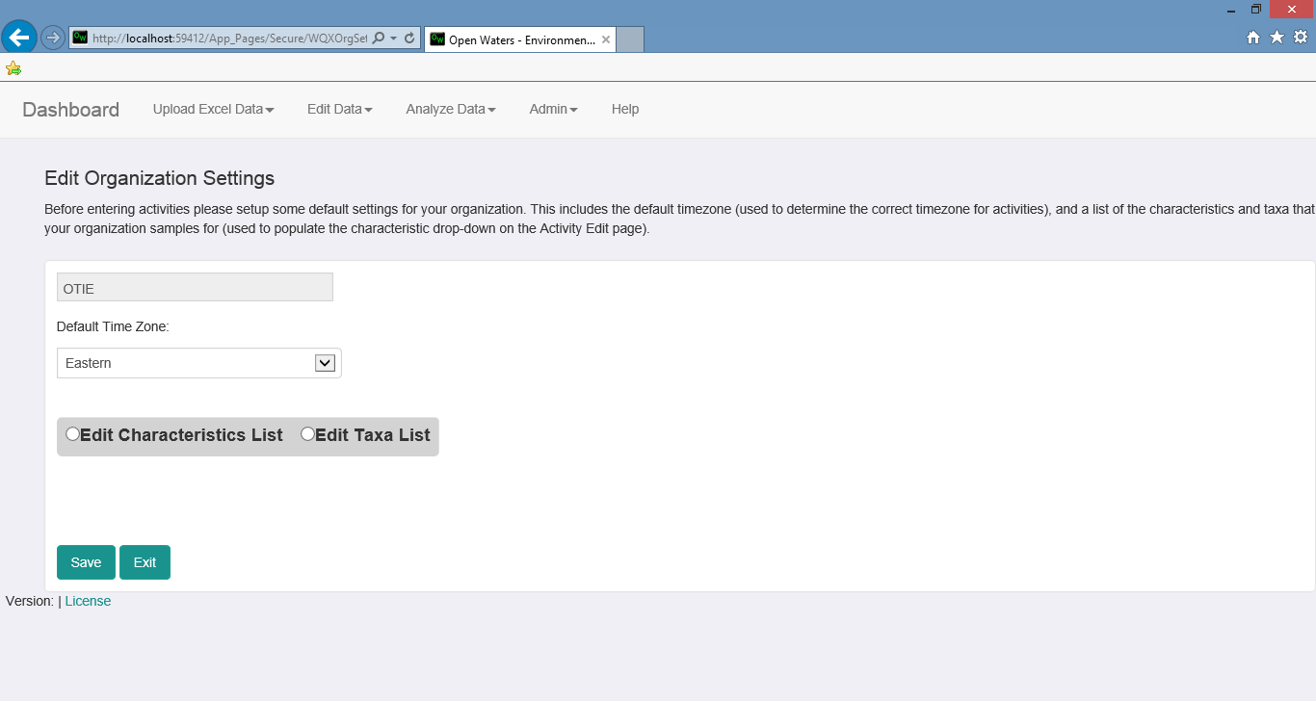

Figure 28: Org Characteristic Settings screen

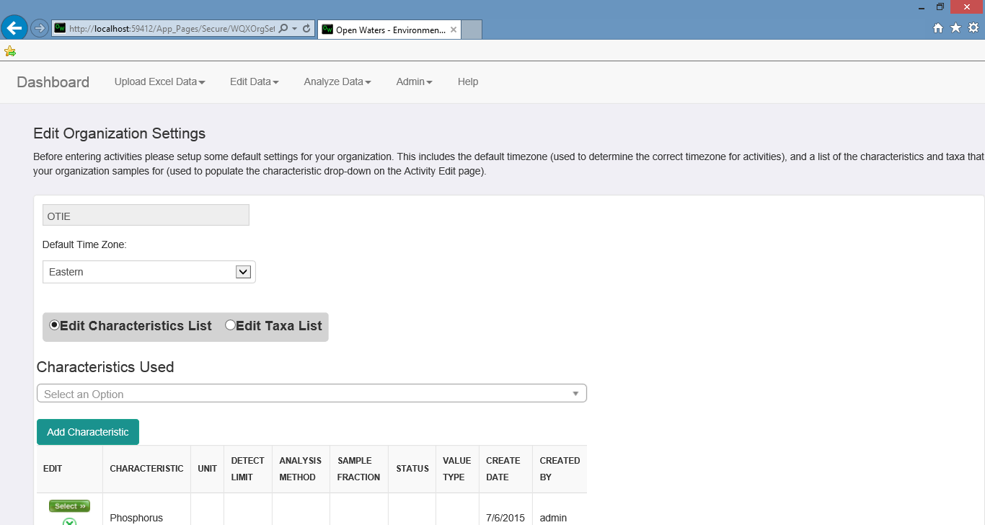

Figure 29: Org Characteristic Settings edit screen

## Column Admin

The Column Admin screen allows you to select which columns are available to be included in an upload configuration file. Additionally, you can select what the Units are for this column of data, and what the minimum and maximum acceptable values are for this column.

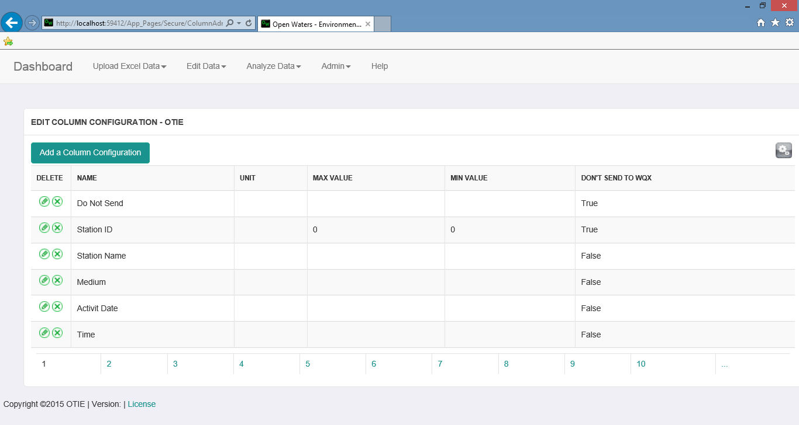

Figure 30: Column Admin screen

## Synch Data

The **Synch Data** screen allows you to synchronize your reference data with the the most current EPA reference data. This needs to be performed when the database is initially setup and when the EPA makes changes to their reference data. This **Synch Data** process takes a while and should not be disrupted while it is running. Additionally, you can view all of the reference data and make changes to most of the tables from this screen.

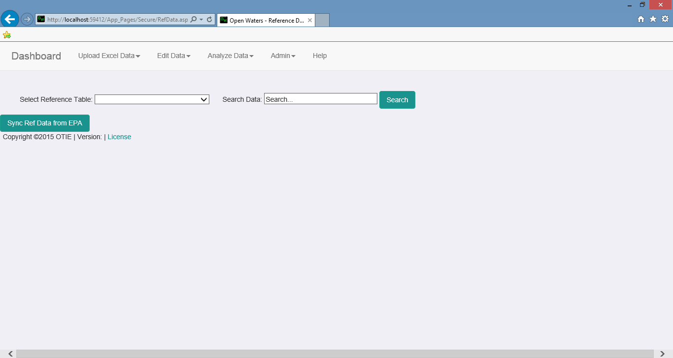

Figure 31: Synch Data screen

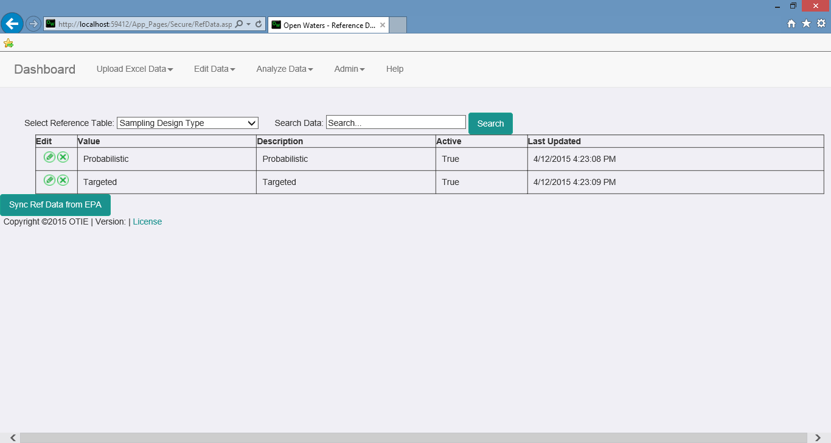

Figure 32: Synch Data screen with Sampling Design Type selected